AWS Lab 1-3

By Jordan Abu-Zahra

**Purpose:**

the purpose of this lab was to learn about Amazon Web Services and practice using their GUI so we can do these things on our own so we could take more Amazon Web Service courses in the future if we want. Another purpose was to try and get our certification for this course to help get us hired for future internships and jobs.

**Background:**

AWS or amazon web services is a cloud computing platform made from amazon. It offers a decently wide rage of cloud computing services, to name a few computing power, storage, and databases, as well as analytics, machine learning, and internet of things. One big advantage of Amazon Web Services is its pricing model, AWS offers a pay as you go pricing model which means that the company that buys your product only pays for exactly what they need / use. Additionally, AWS offers many different pricing options that include spot instances, reserved instances, and on demand instances, which will help businesses save money on their computing costs. Another advantage is that AWS have amazing security, AWS offers a variety of tools and services to help businesses / customers build and manage their applications. This includes features like development and deployment, AWS lambda, AWS elastic beanstalk, and AWS Code Deploy. They also offer a variety of tools for managing and monitoring applications, such as AWS cloud watch, Aws config, and AWS cloud trail. AWS has become one of the most popular and widely used cloud computing platforms in the world, and for good reasons. With its flexible pricing, robust security, and extensive range of tools and services, AWS is a great choice for businesses of all sizes that are looking to leverage the power of cloud computing

**Lab 1** **Introduction to AWS IAM**

Step 1: Click “start lab” and wait for the lab to load.

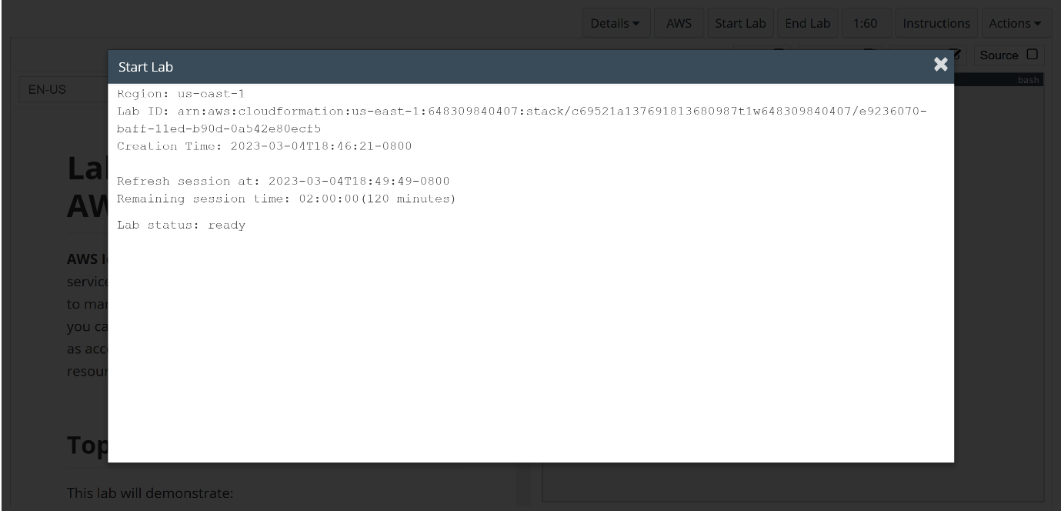

Step 2: Click “AWS”

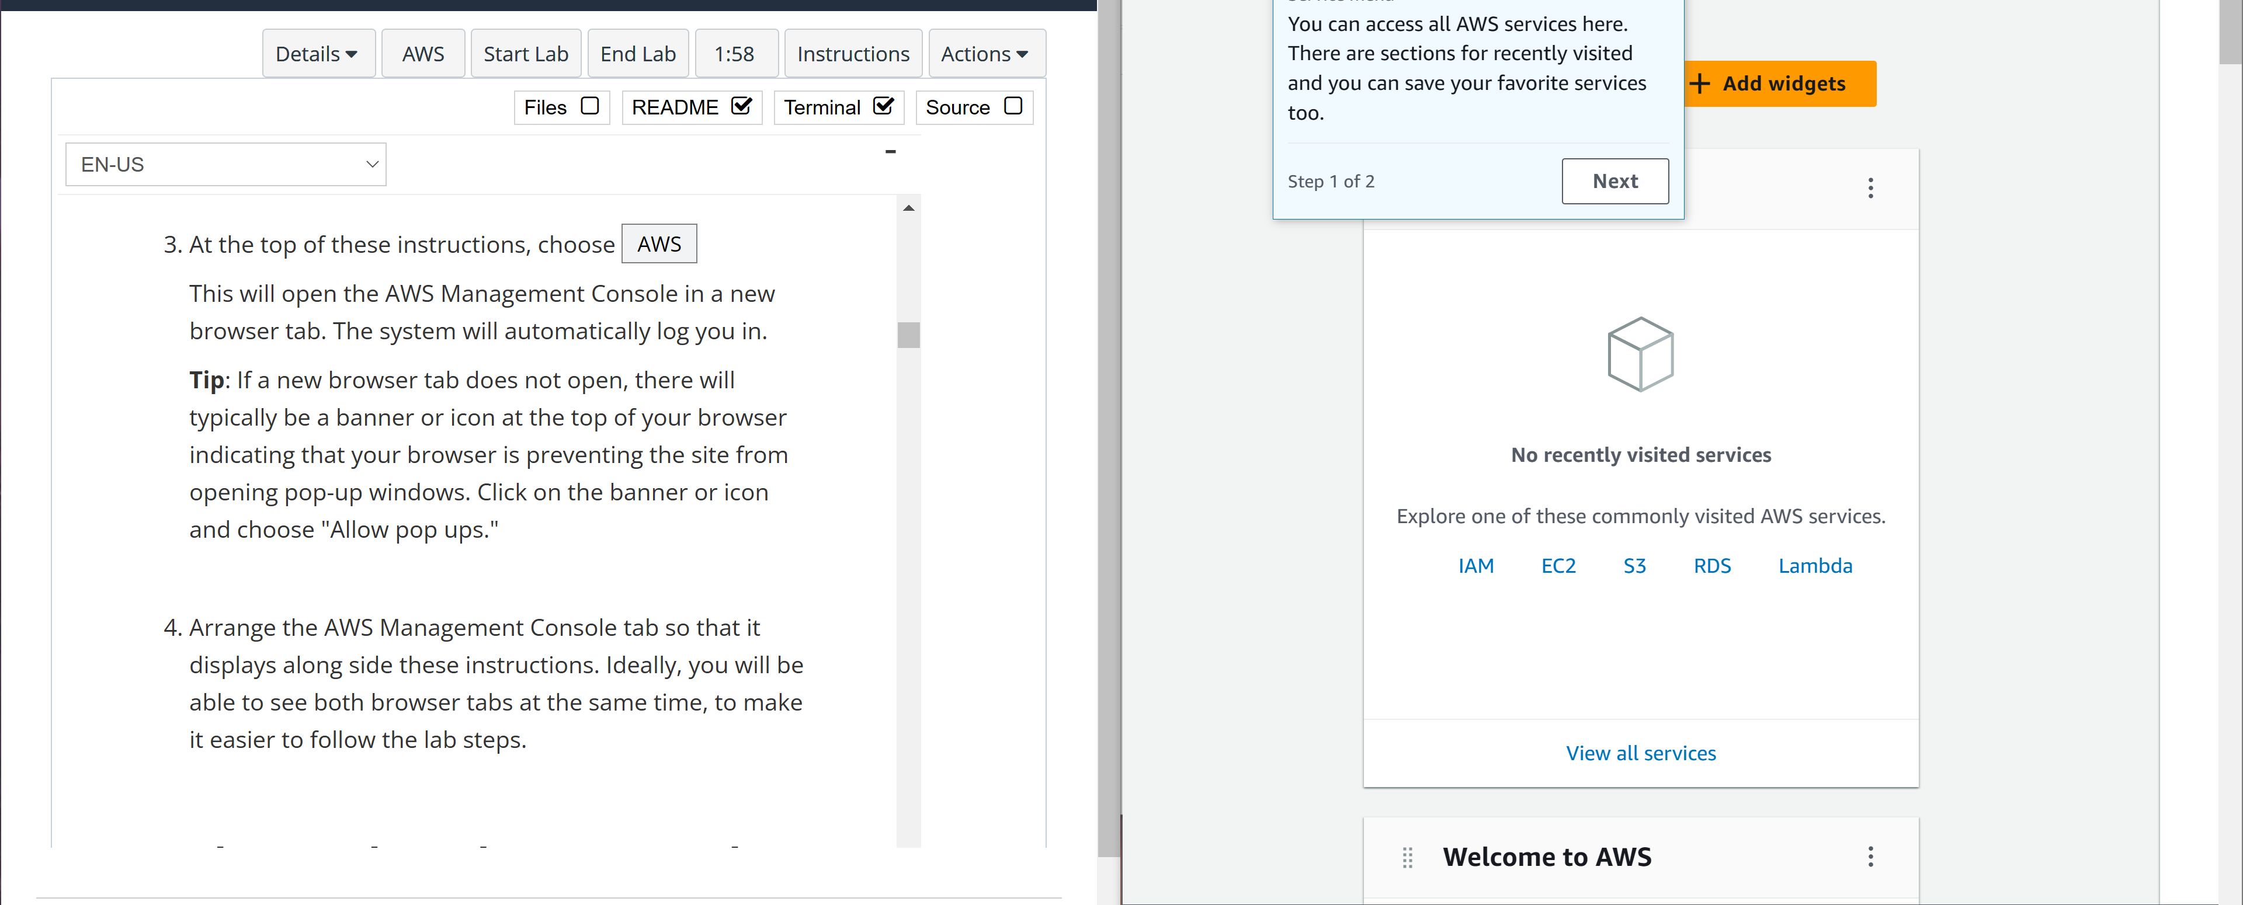

Step 3: in the AWS management console, go to services and select IAM.

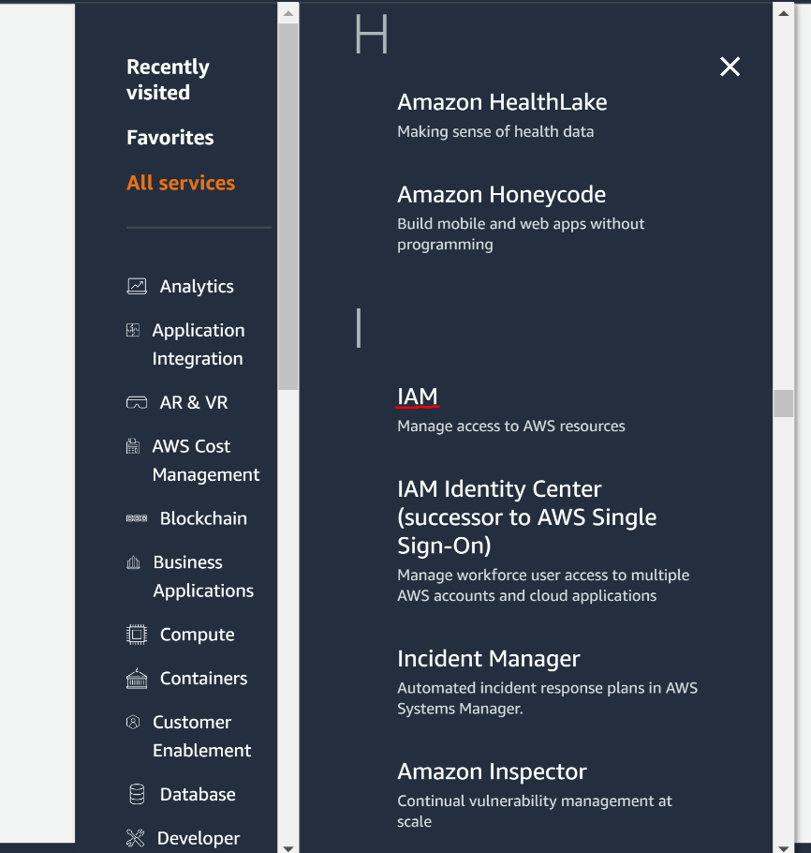

Step 4: Select “user groups”

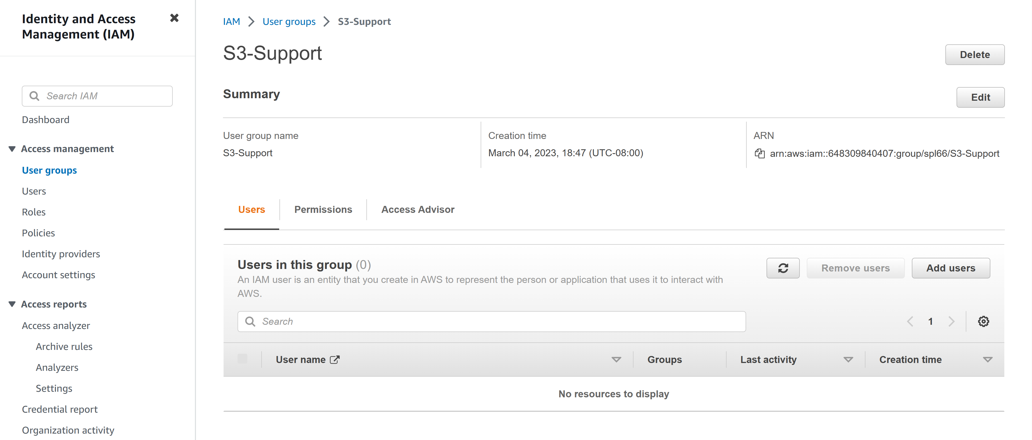

Step 5: select “add users”

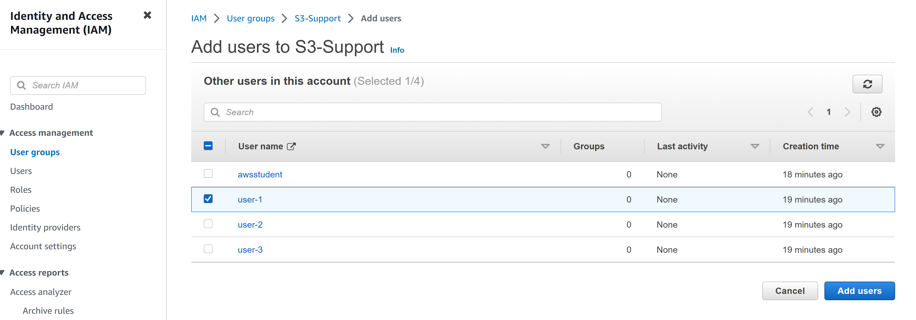

Step 6: add “user-2” to EC2-Support

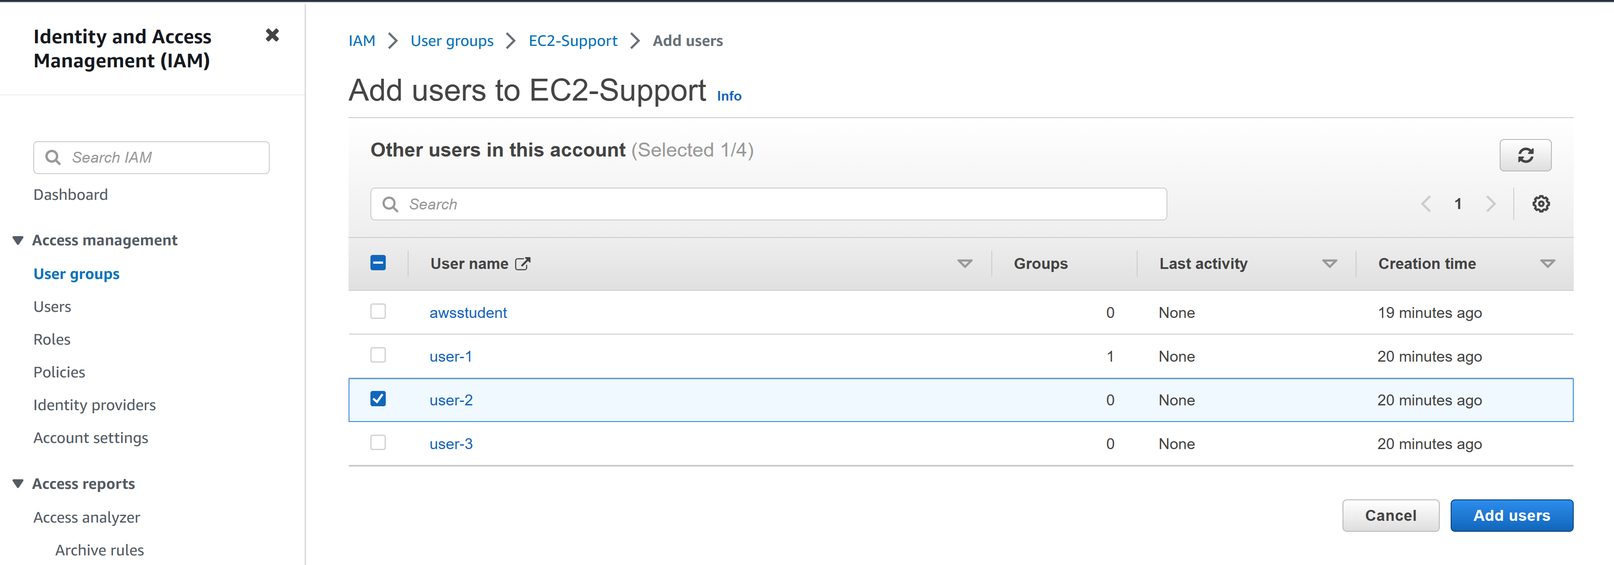

Step 7: add “user-3” to EC2-Admin

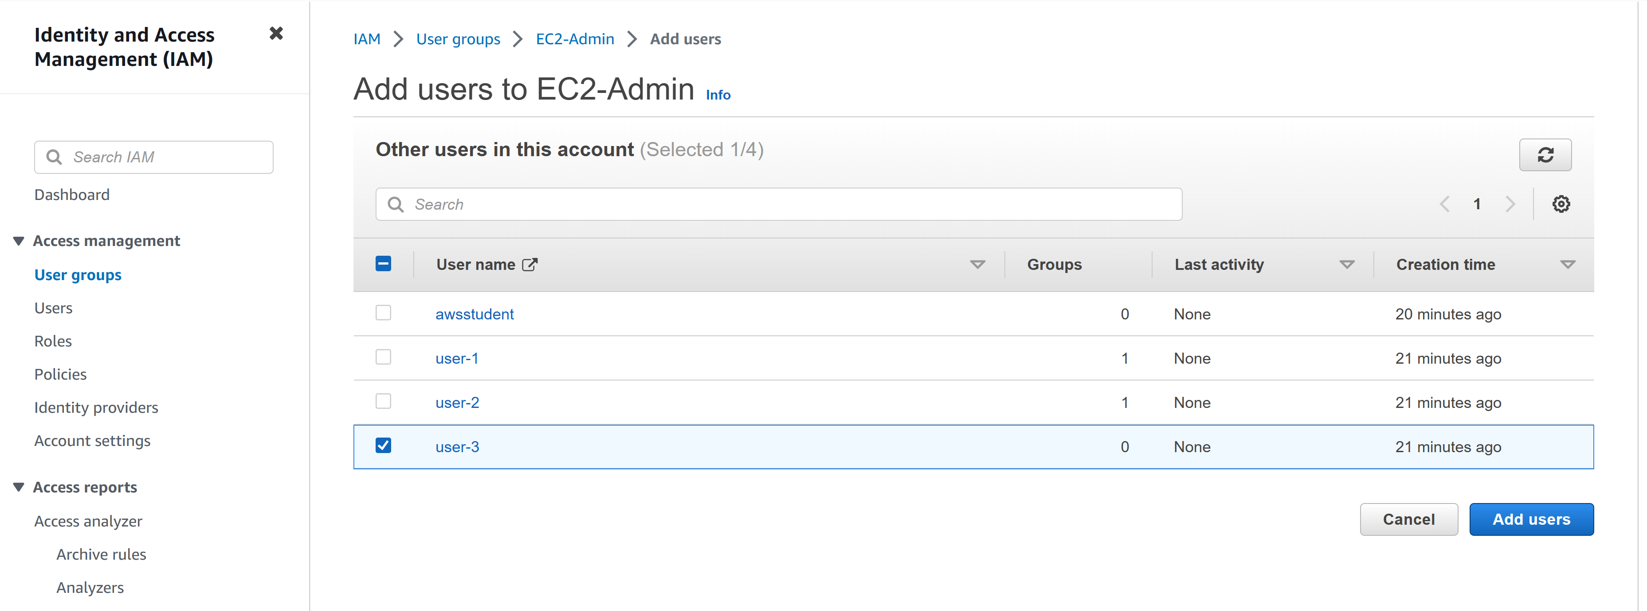

Step 8: go to the dashboard and find the management console link. Copy the link and open it in a new tab.

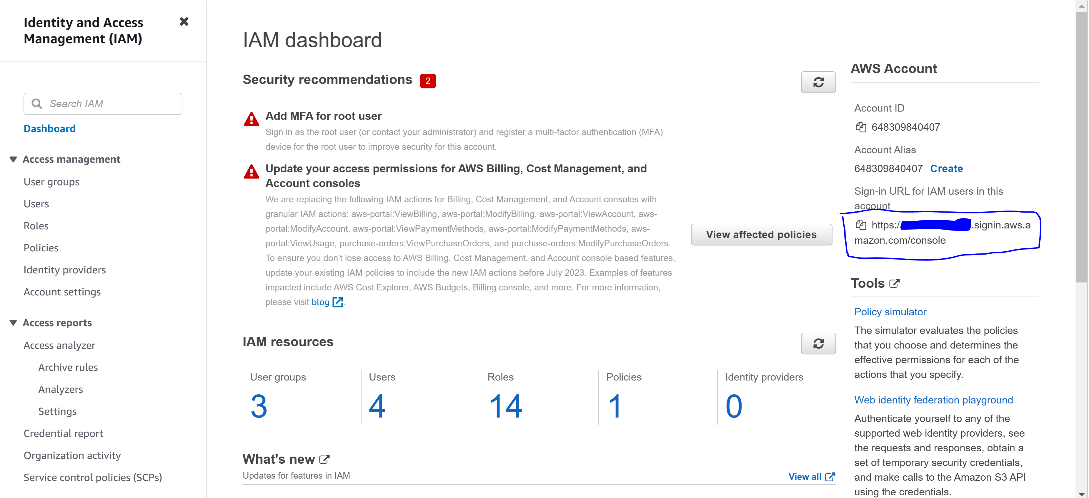

Log in with

User: user-1

Pass: Lab-Password1

Step 9: Go to “services” and “s3”. You should be able to open the bucket since you have permission.

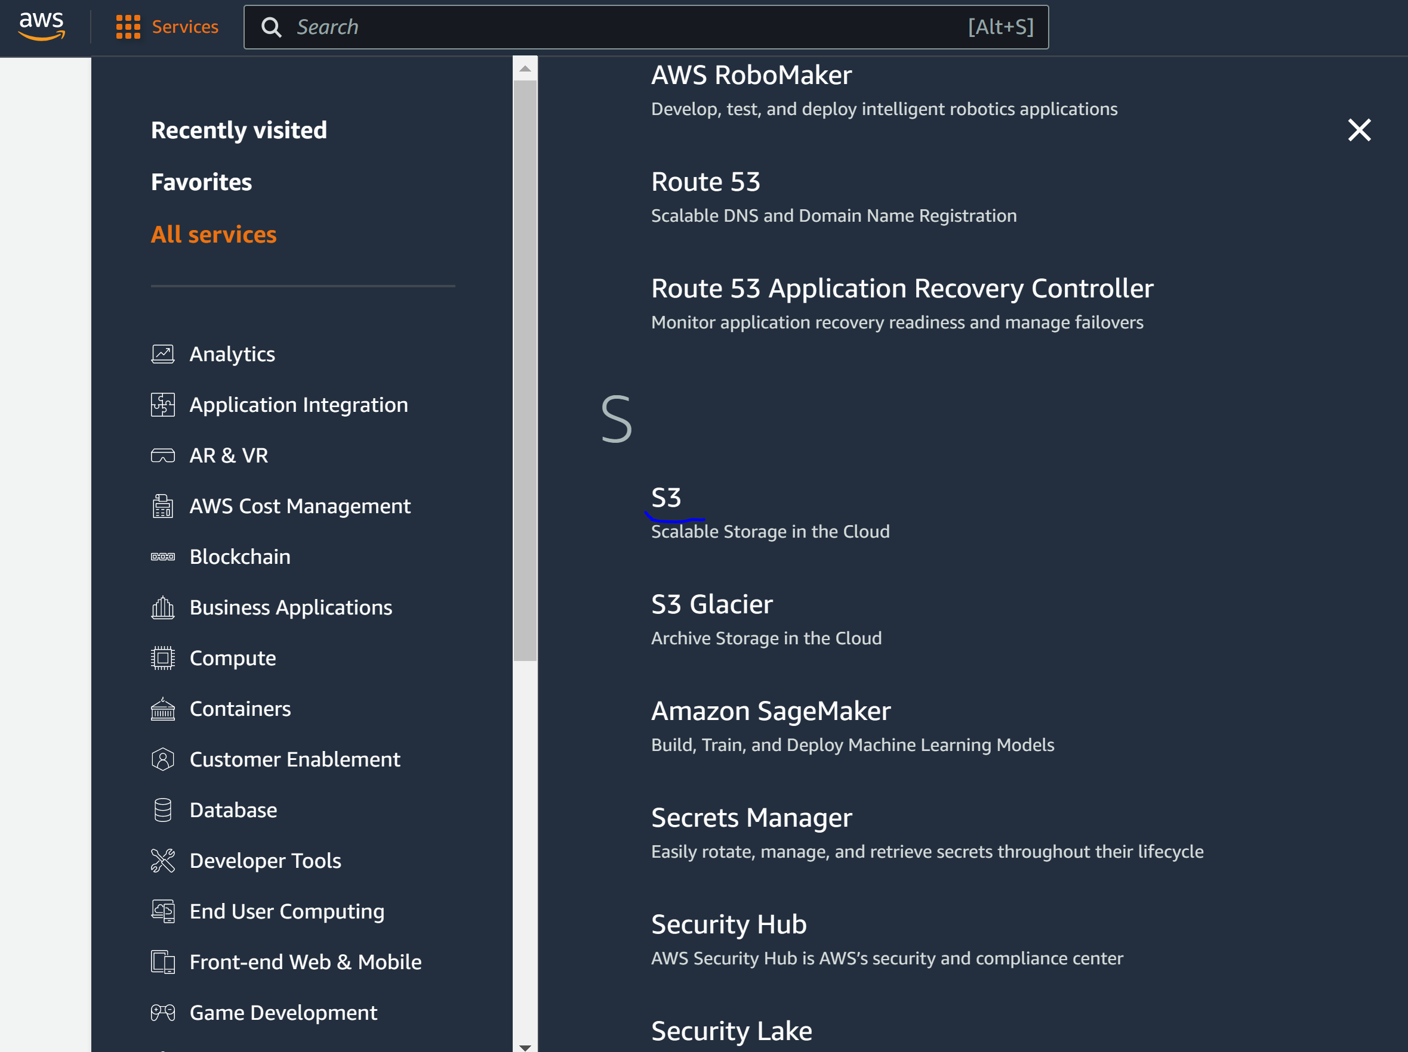

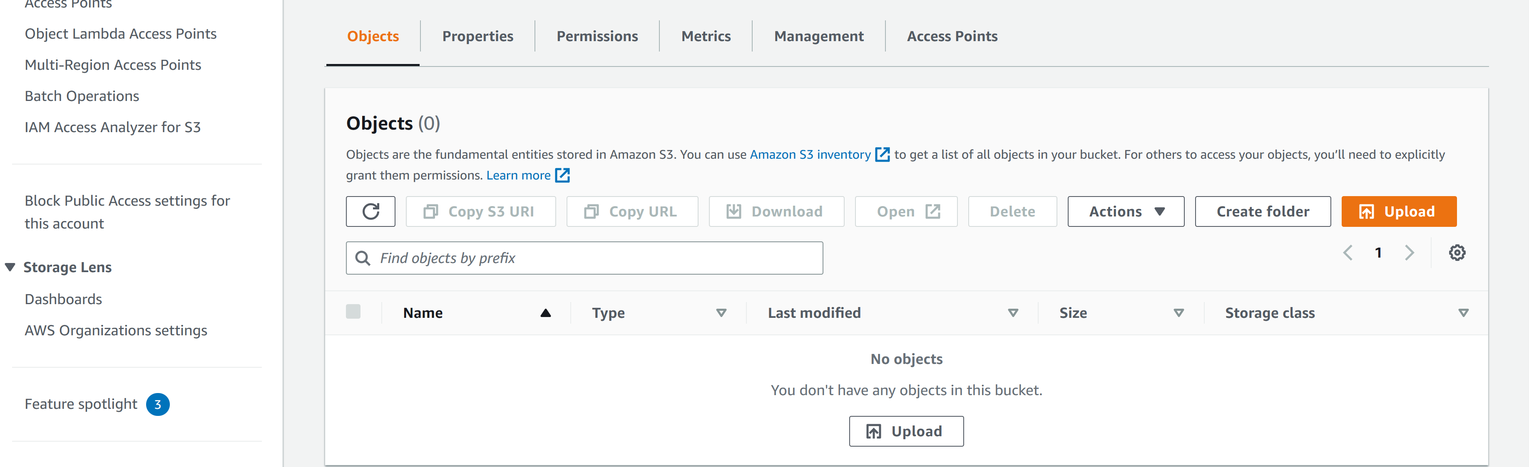

Step 10: Got to “services” and “ec2.” You shouldn’t have authorization.

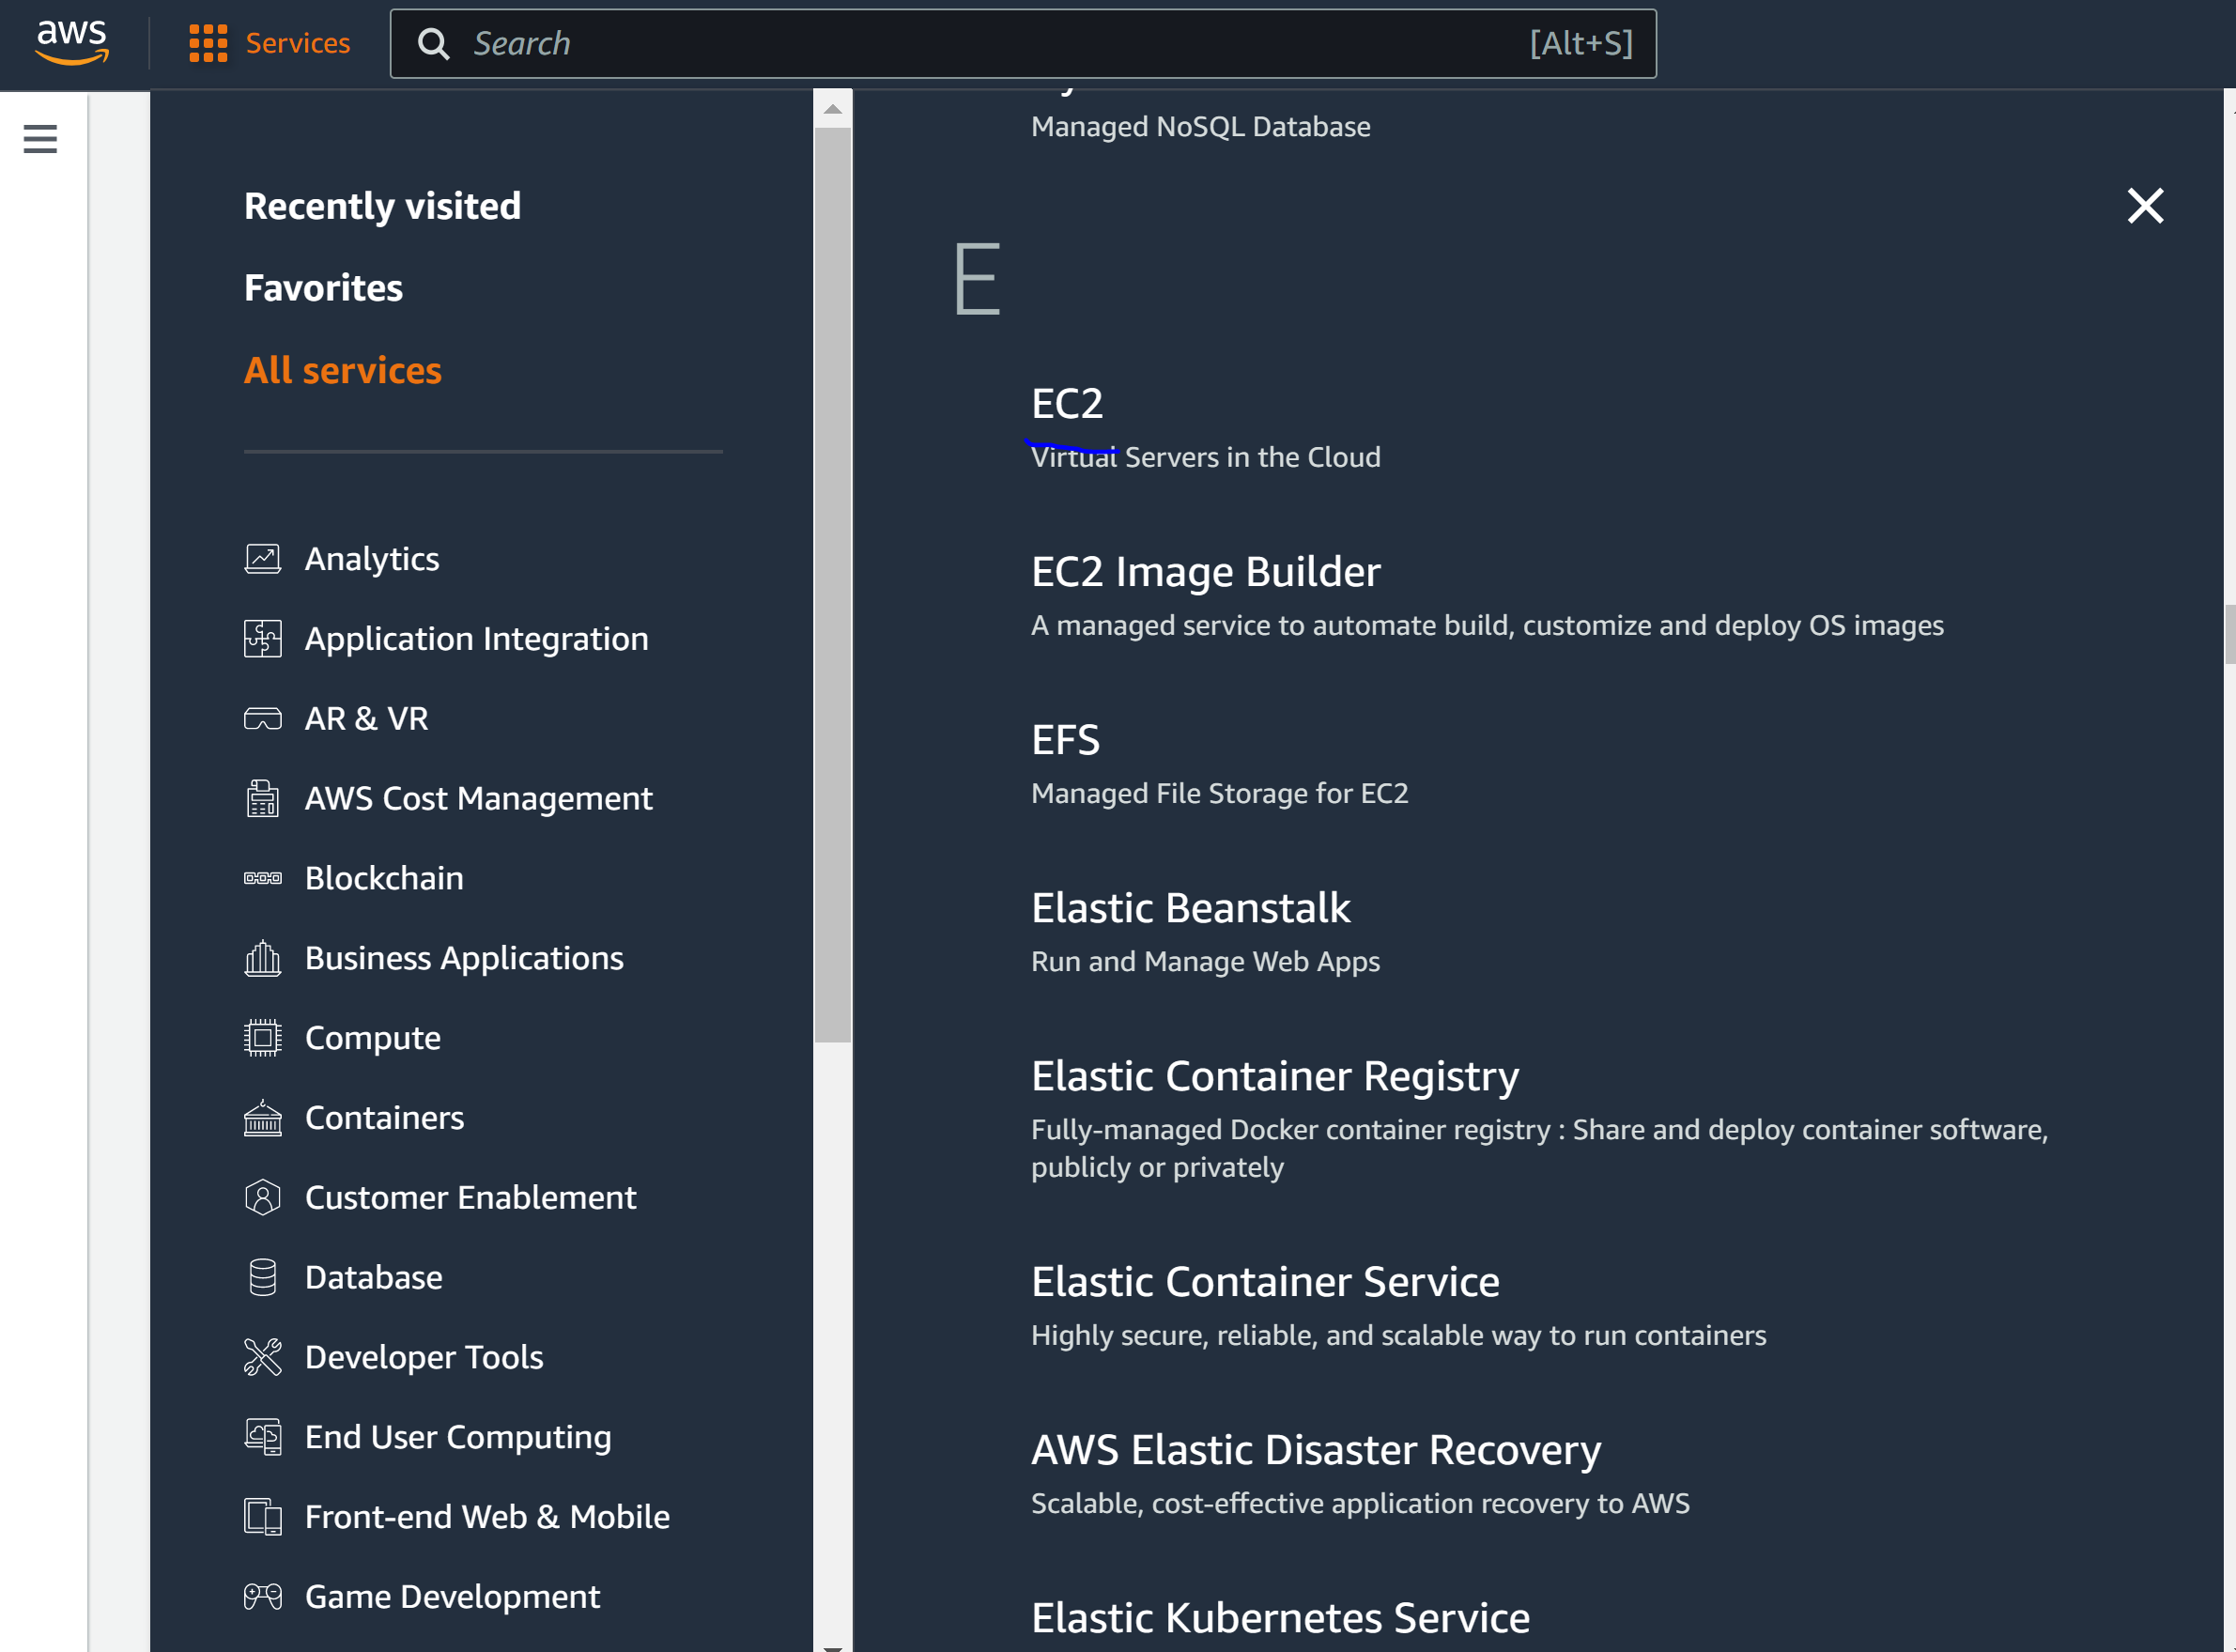

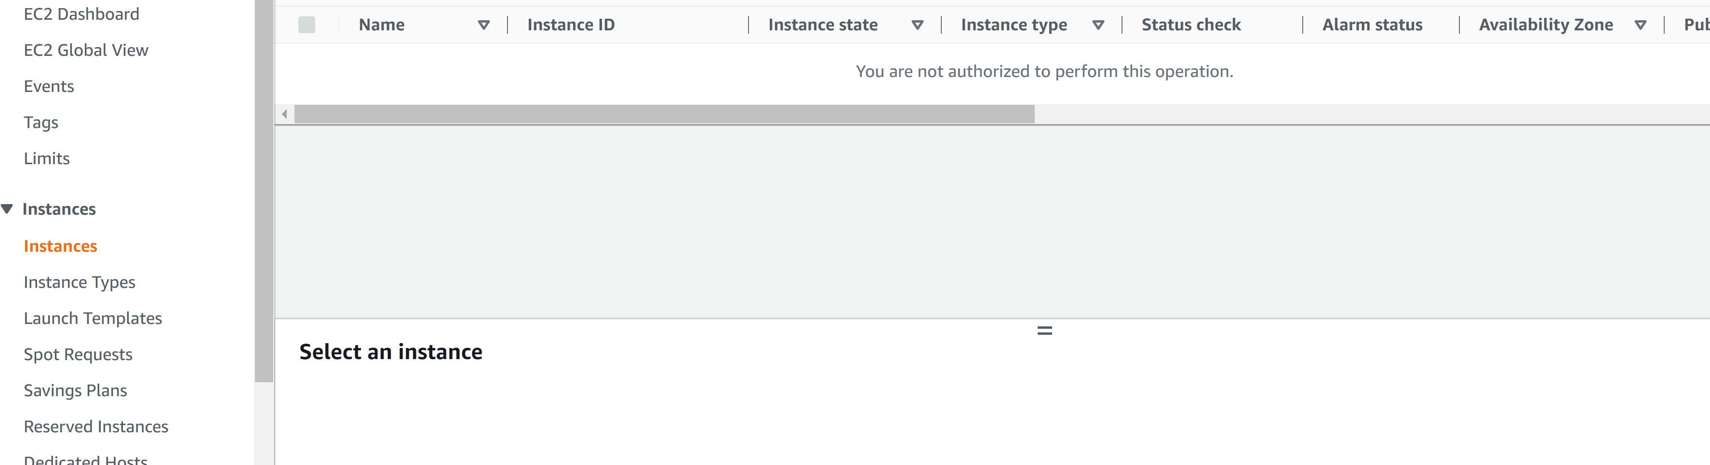

Step 11: log out of user-1 and log into user-2 with

* User: user-2
* Pass: Lab-Password2

Step 12: go to EC2 instances on user-2. You should have permission to view it.

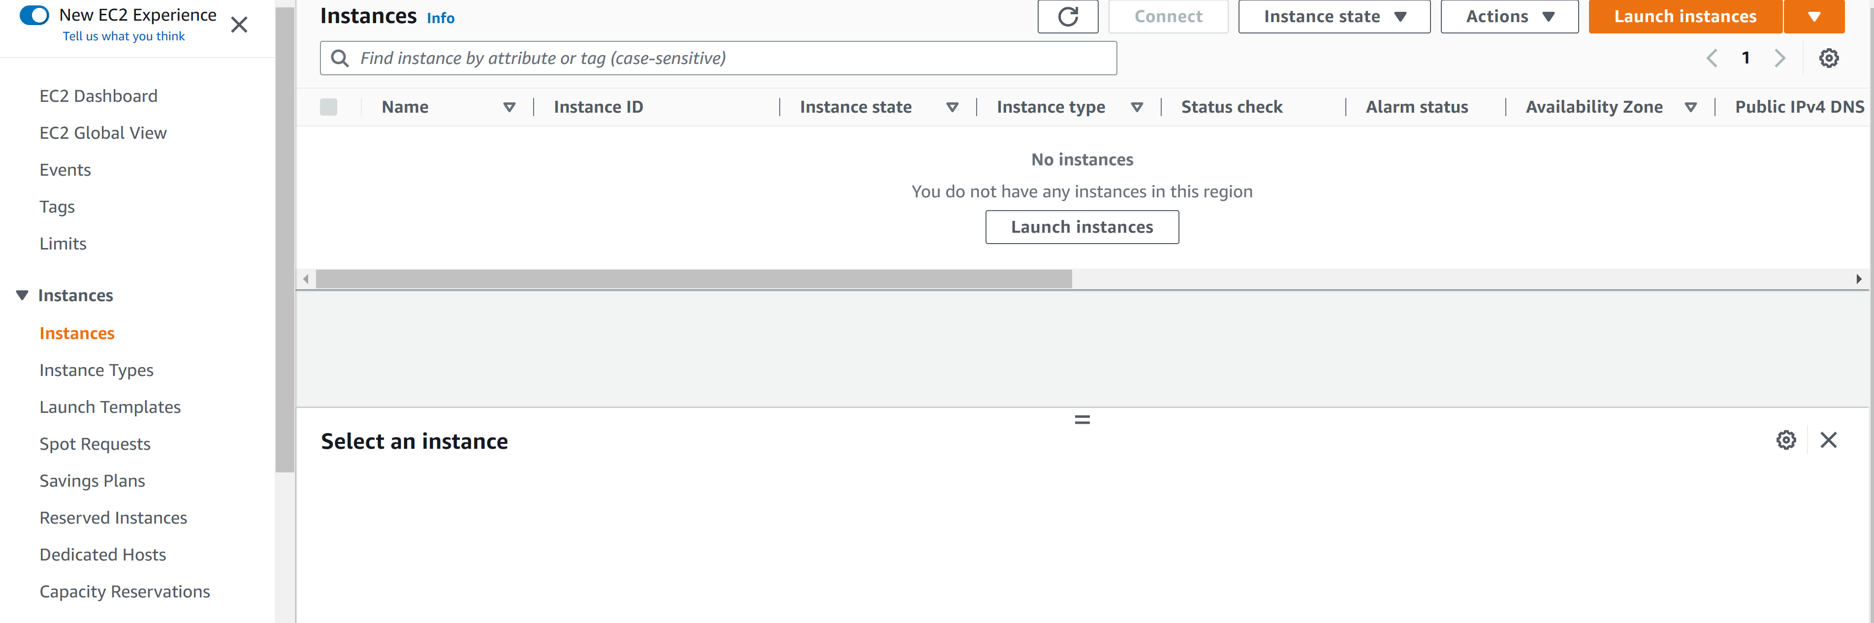

Step 13: go the region where the EC2 instances are. In this case, they are in N. Virginia

Step 14: Stop the instance

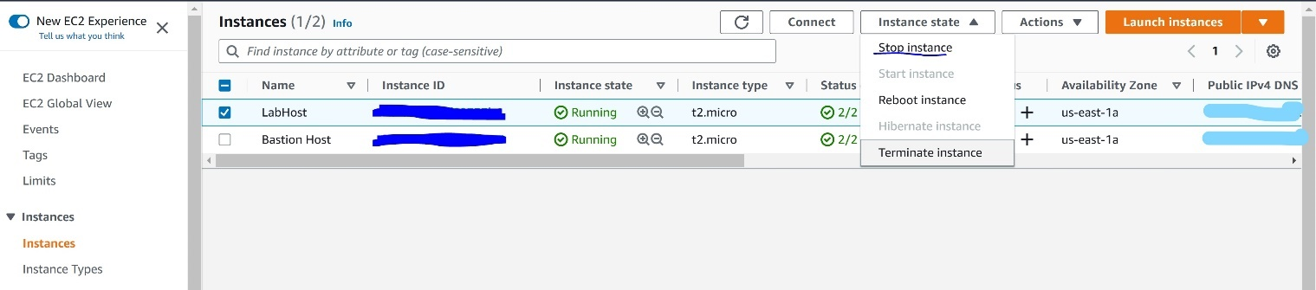

An error message should appear since user-2 only has read-only permissions.

Step 15: Sign out of user-2 and sign into user-3 with the following credentials

* User: user-3
* Pass: Lab-Password3

Step 16: go to EC2 instances and stop the LabHost instance. This should be successful.

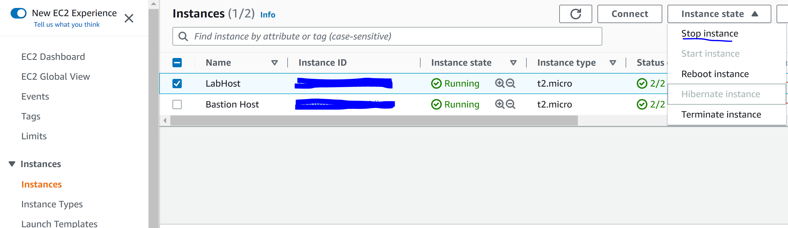

Step 17: end the lab.

**Lab 2** **Build a VPC and launch a Web Server**

Step 1: Click “start lab” and click “aws”

Step 2: verify that the region is N. Virginia



Step 3: open “services” and got to “VPC”

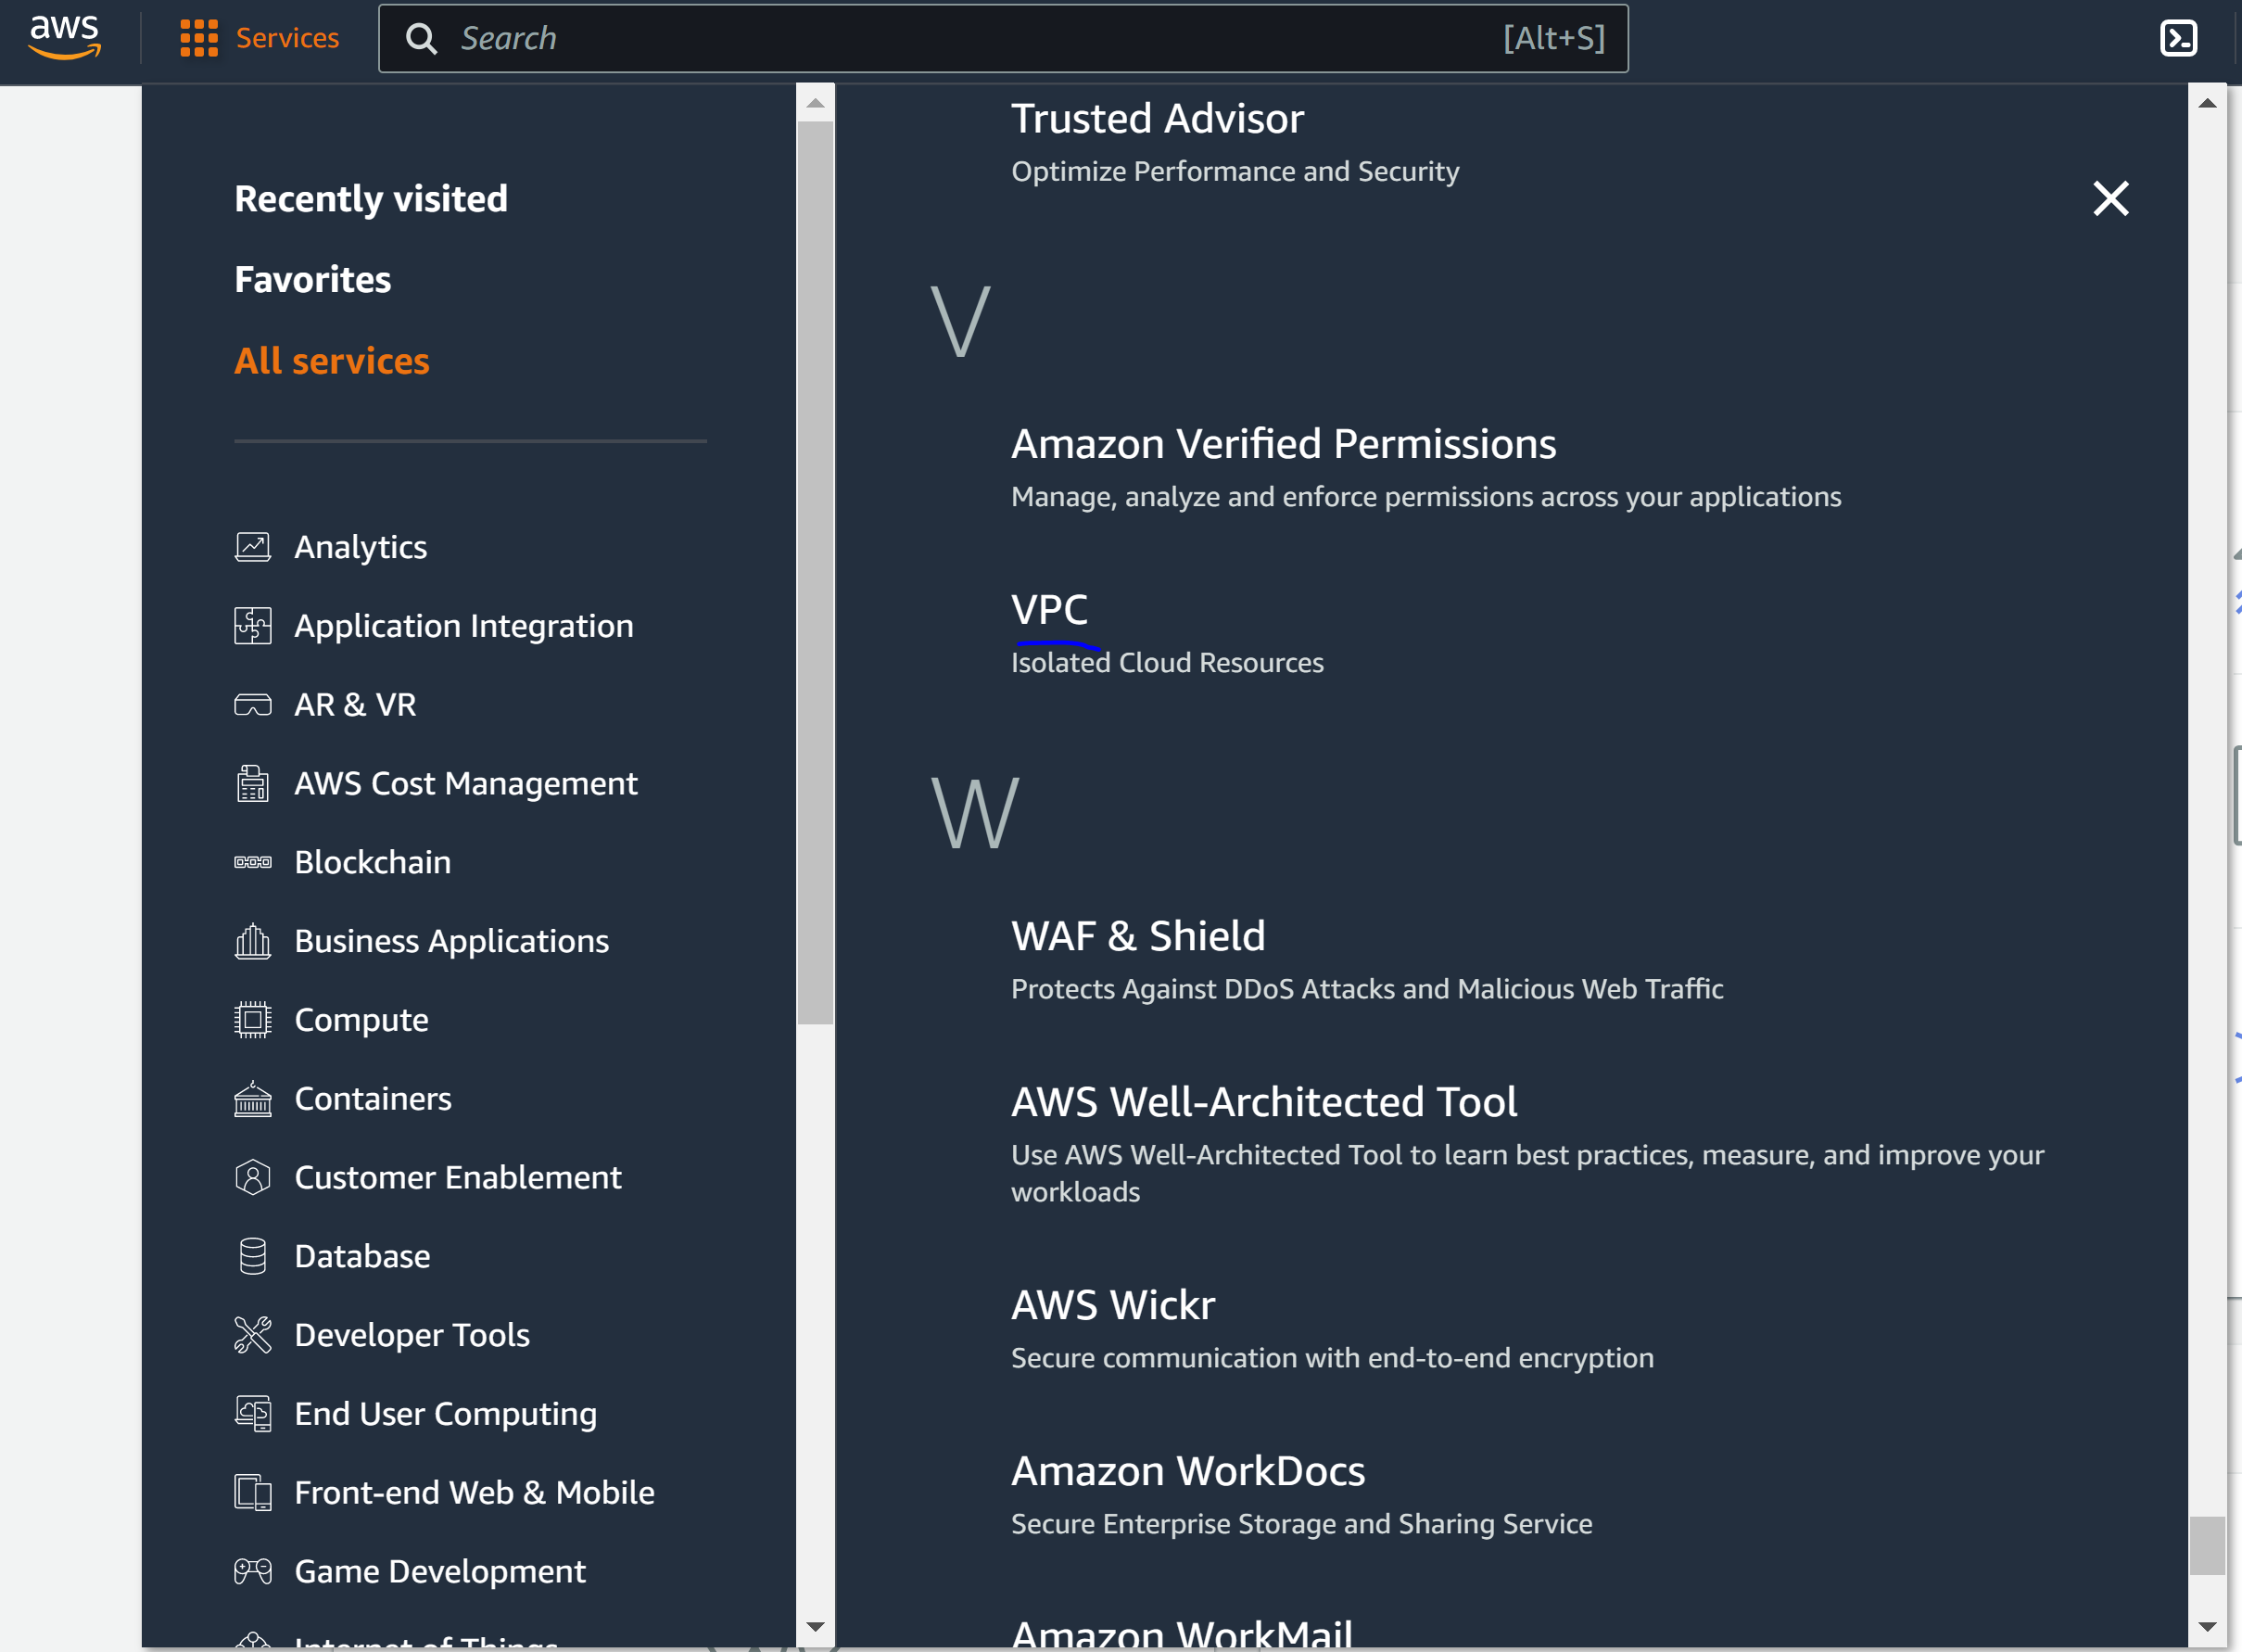

Step 4: Create VPC

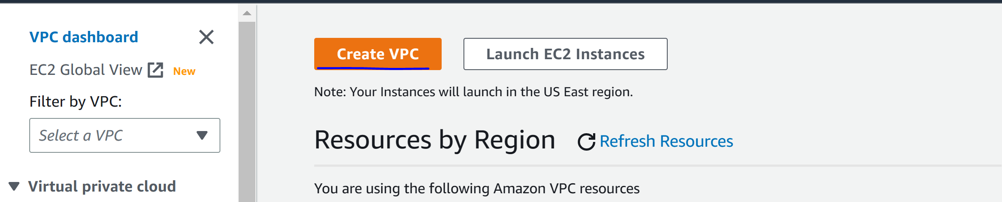

Step 4: configure the following

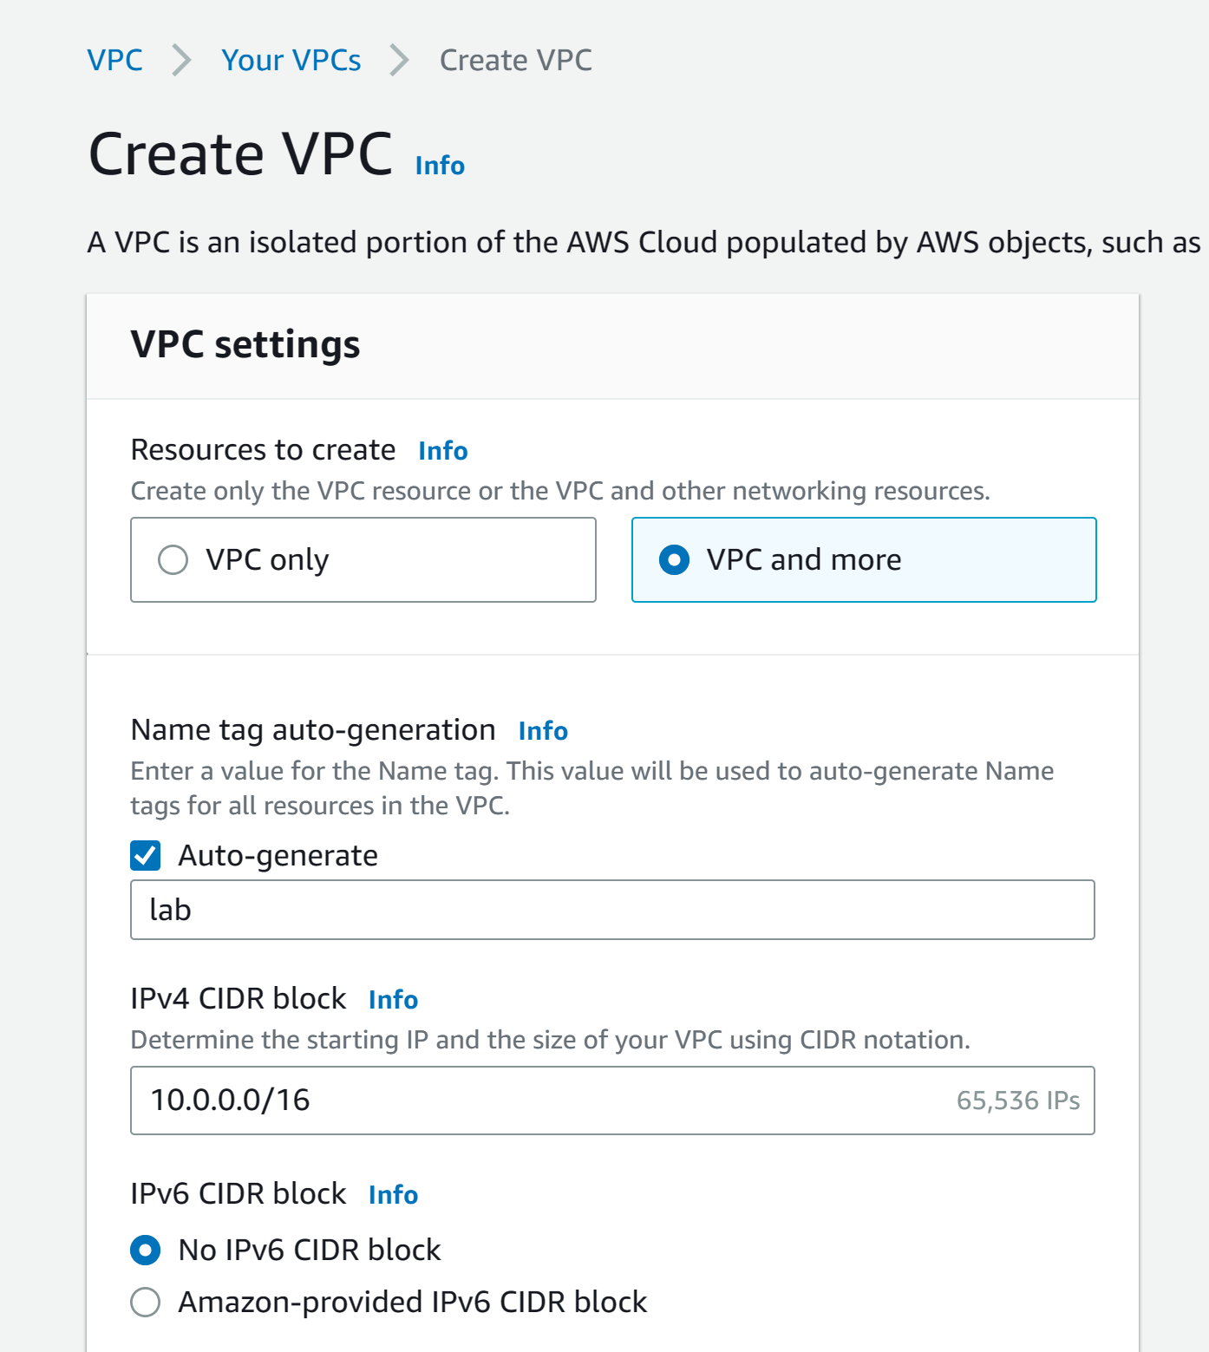

Step 5: configure the following

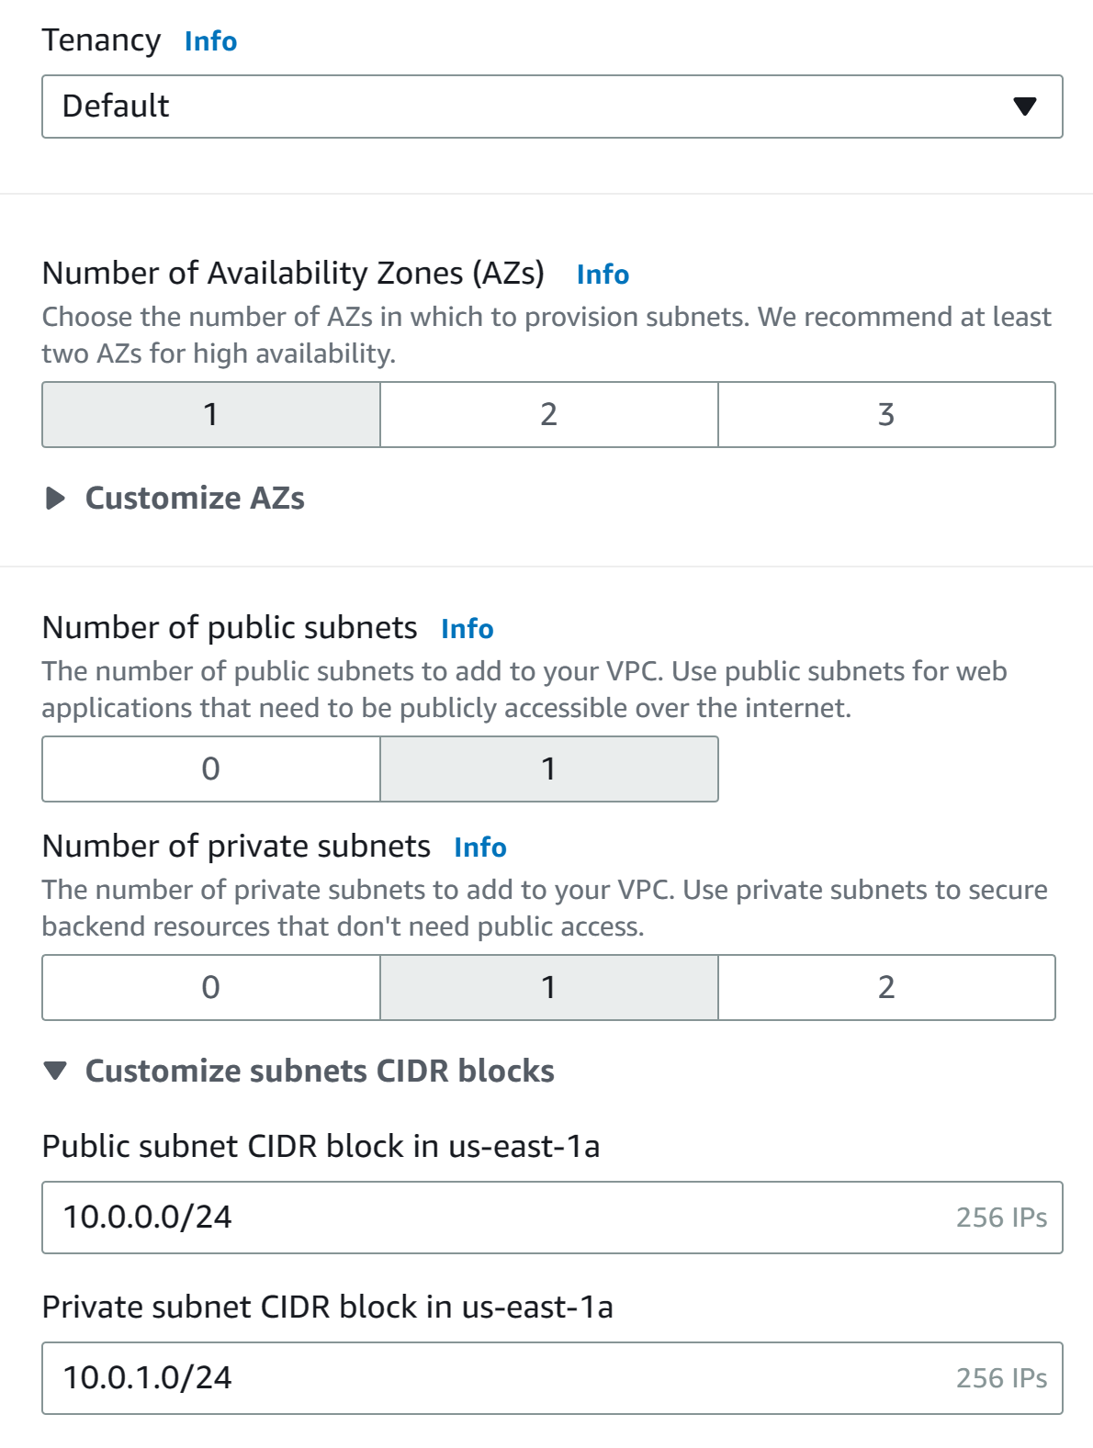

Step 6: configure the following. Click “create VPC” and wait for all resources to activate.

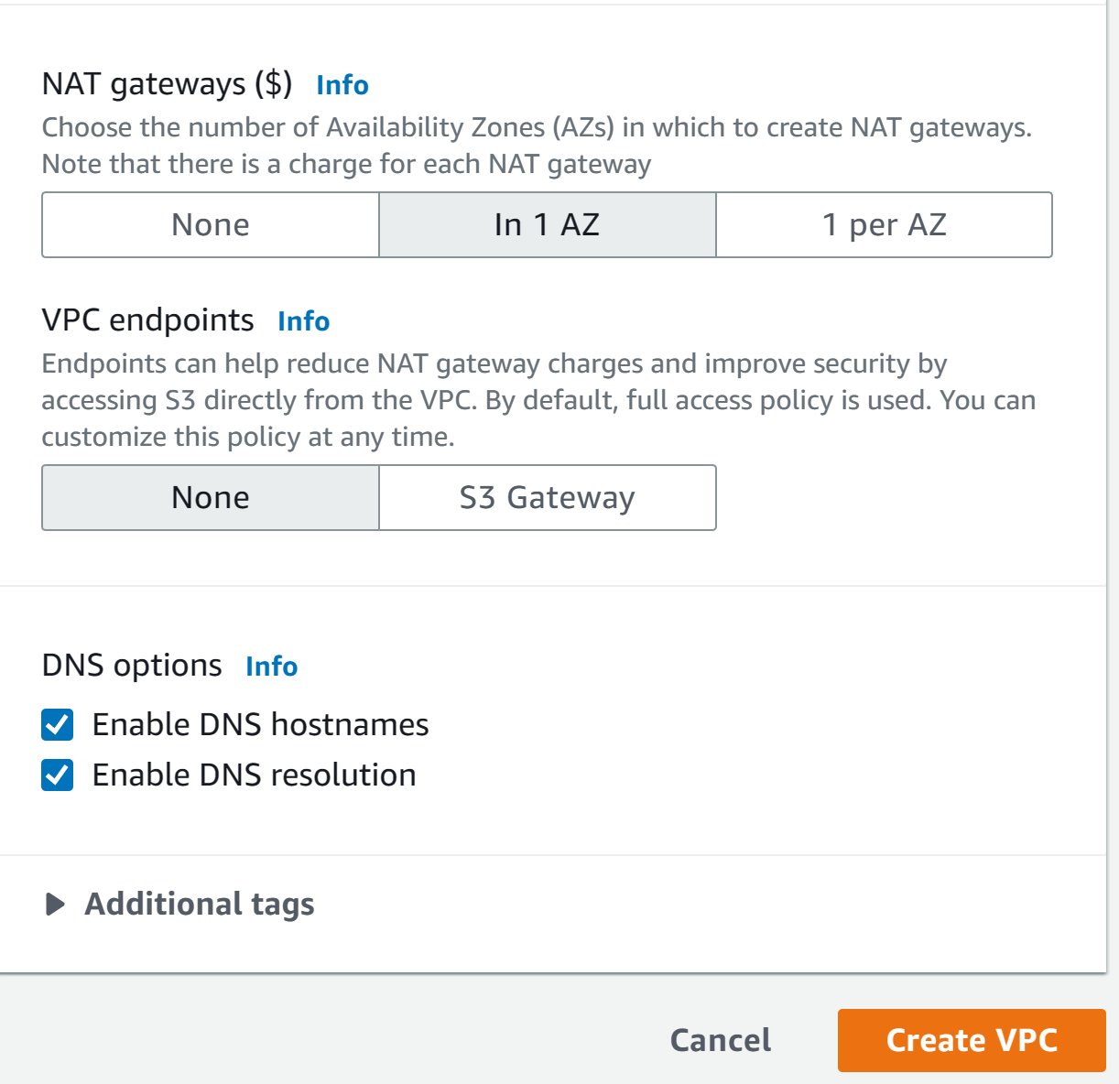

Step 7: click “view VPC”

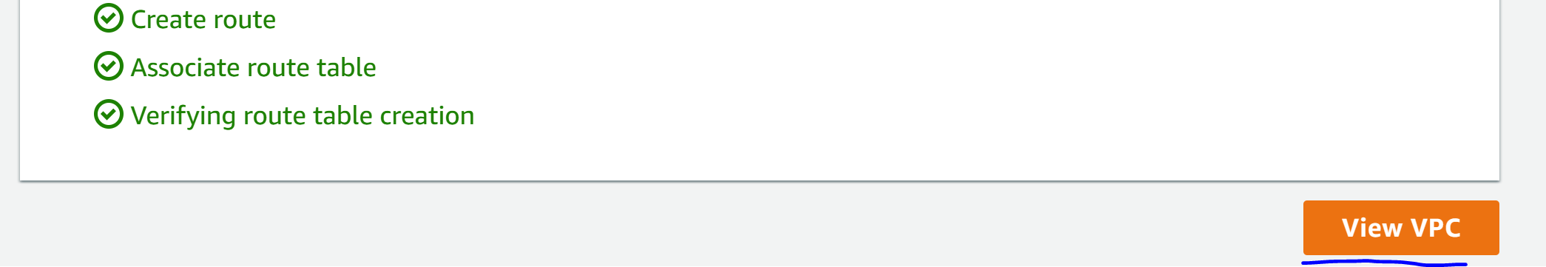

Step 8: click “subnets”

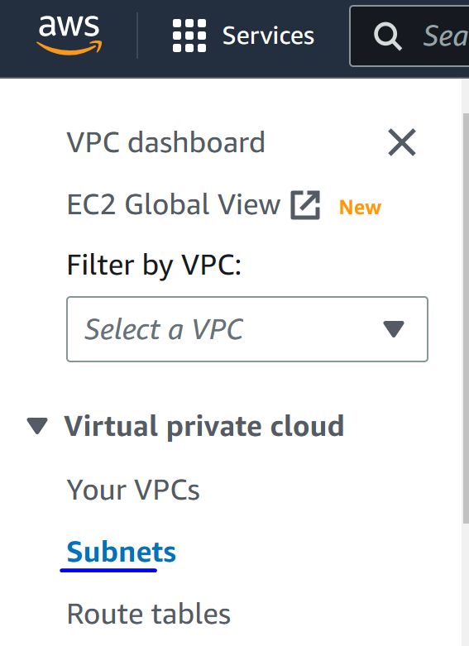

Step 9: click “create subnet” and configure the following. Create subnet.

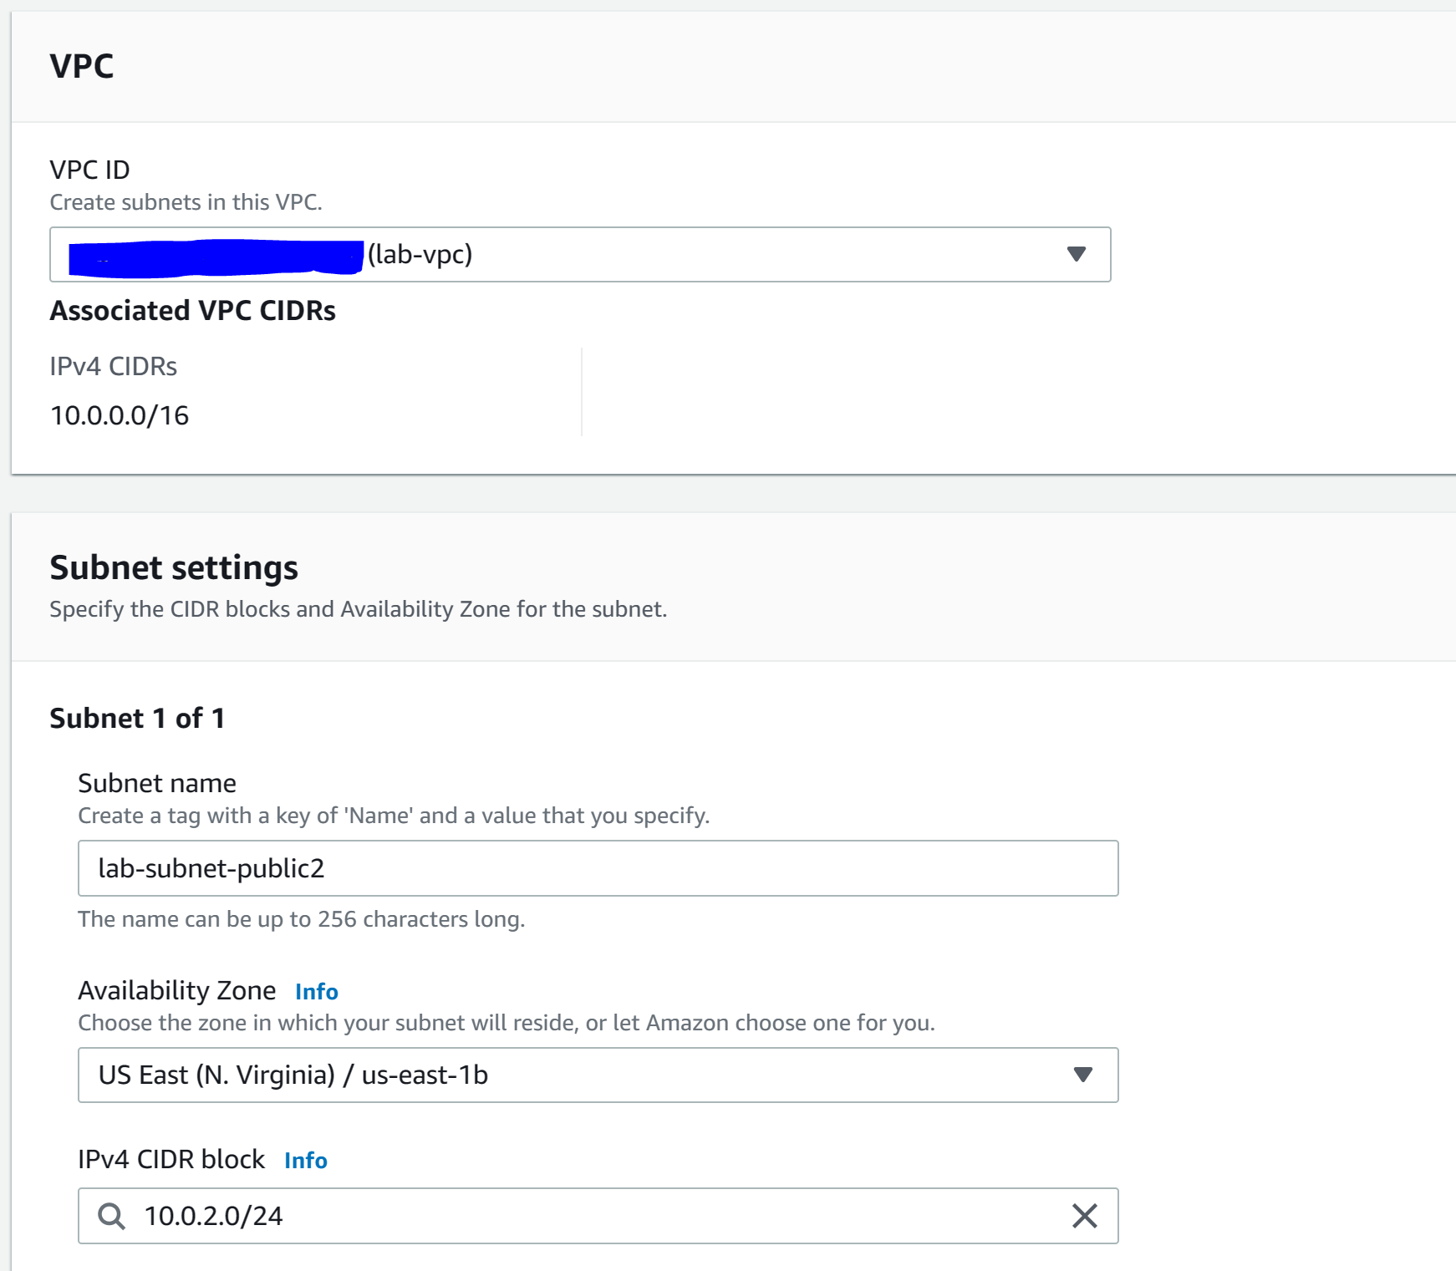

Step 10: click “create subnet” and configure the following. Create subnet.

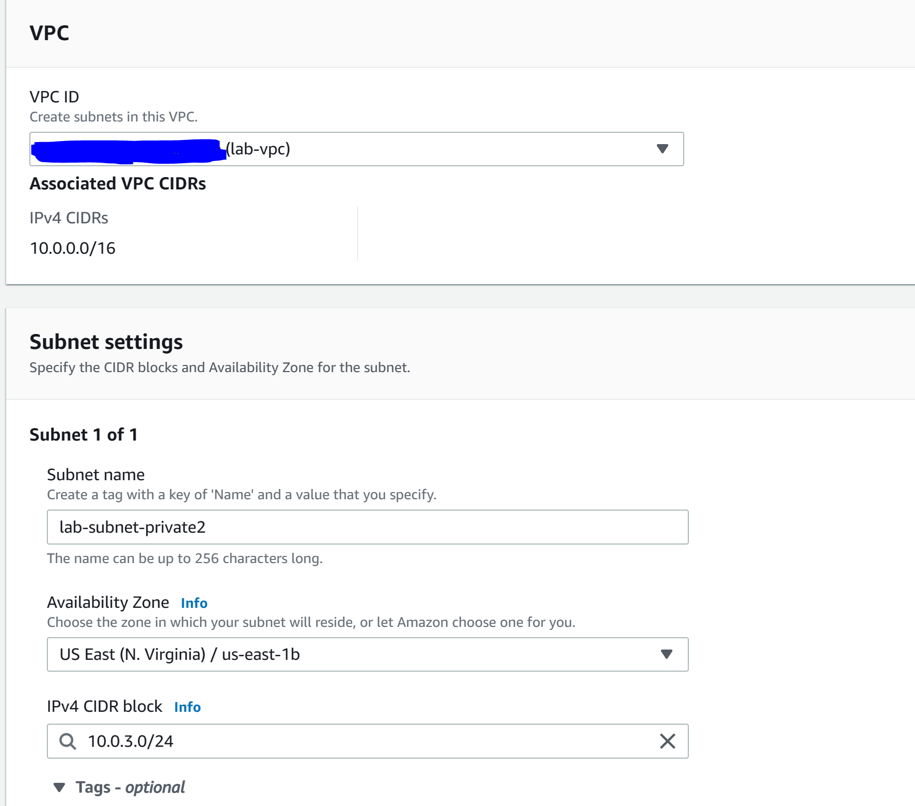

Step 11: Go to “routing tables”, click “lab-rtb-private…” and got to “subnet associations”. Click “edit subnet associations.”

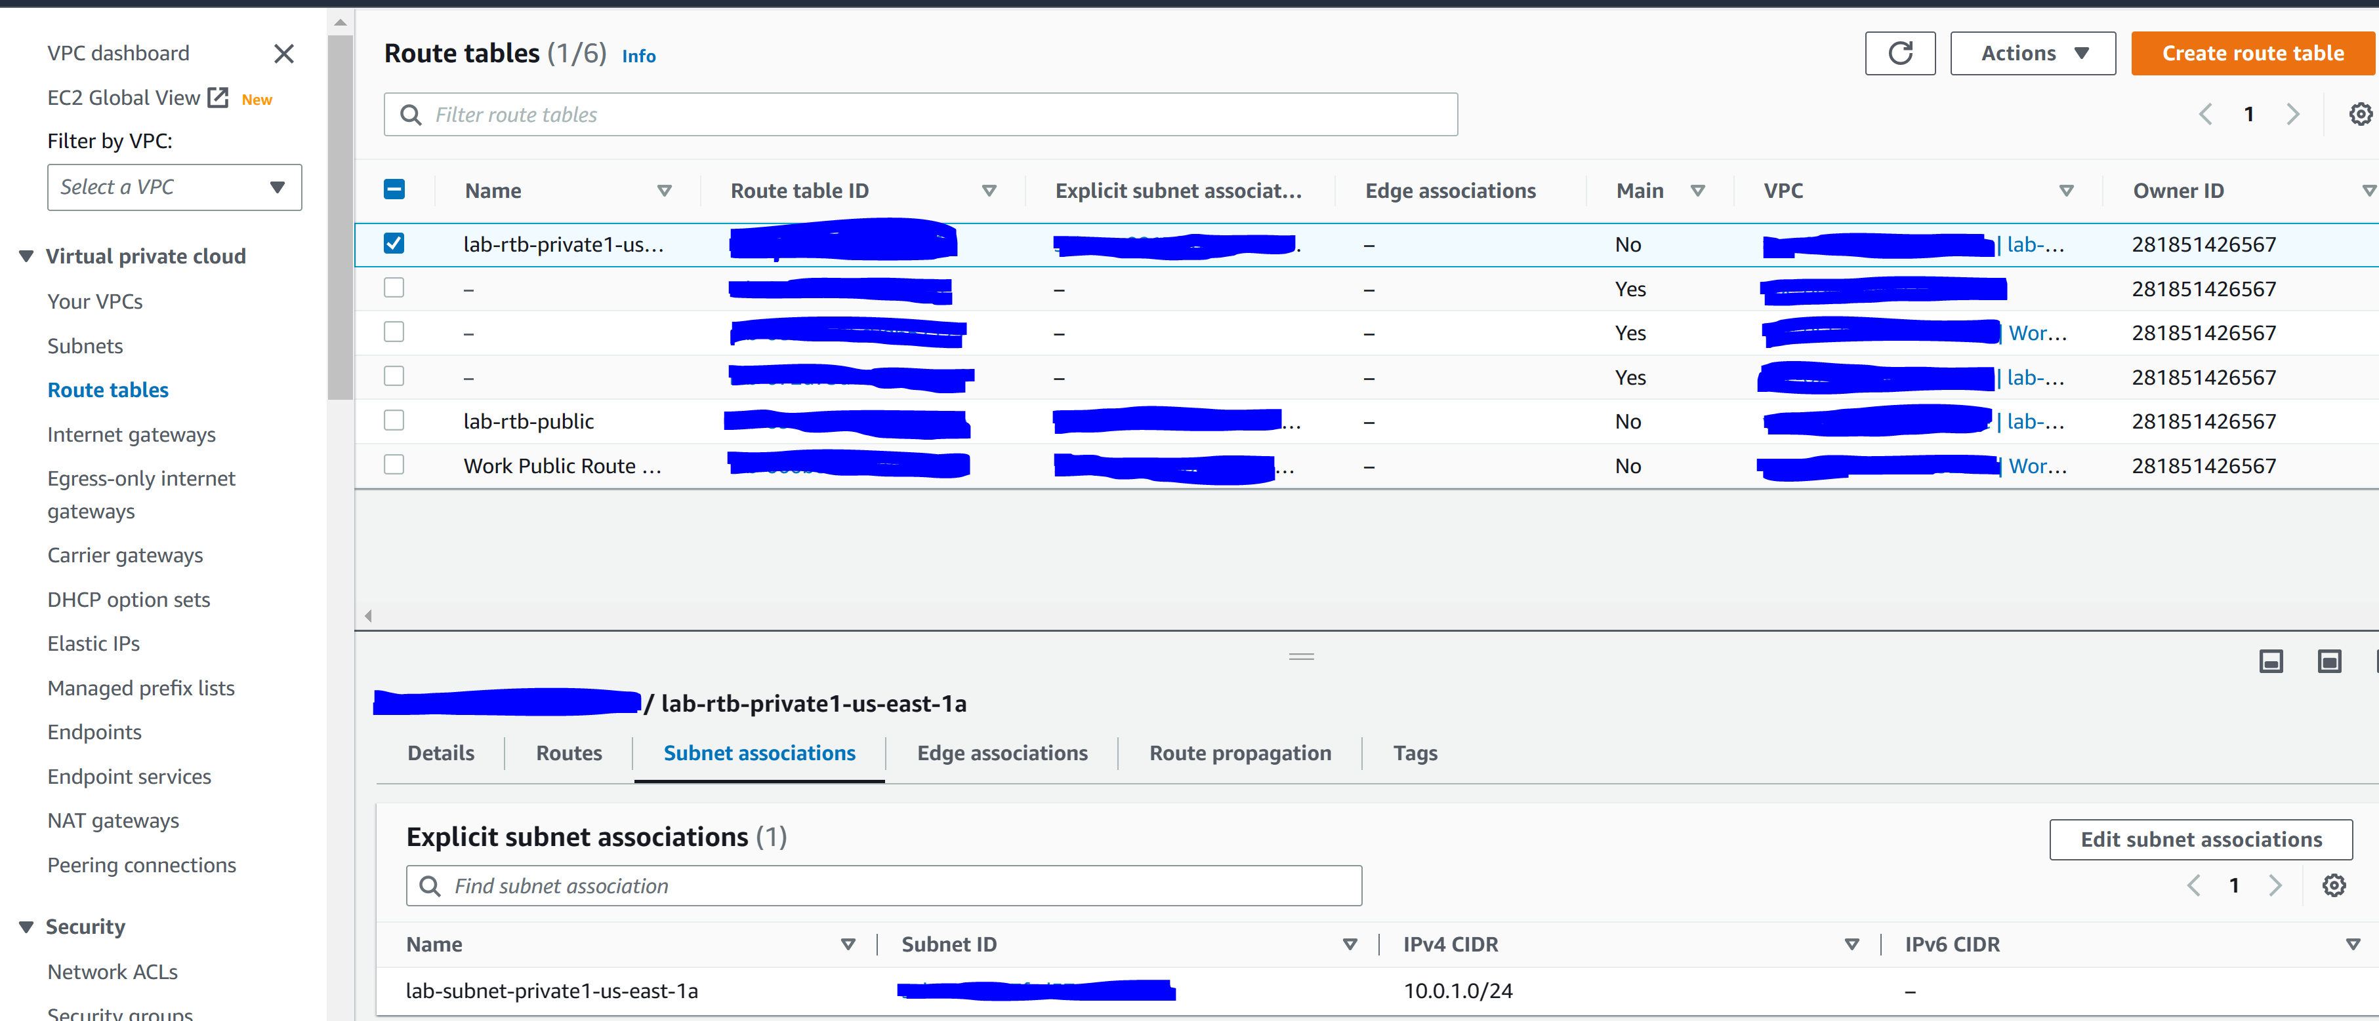

Step 12: select “lab-subnet-private2.” Click “save associations”

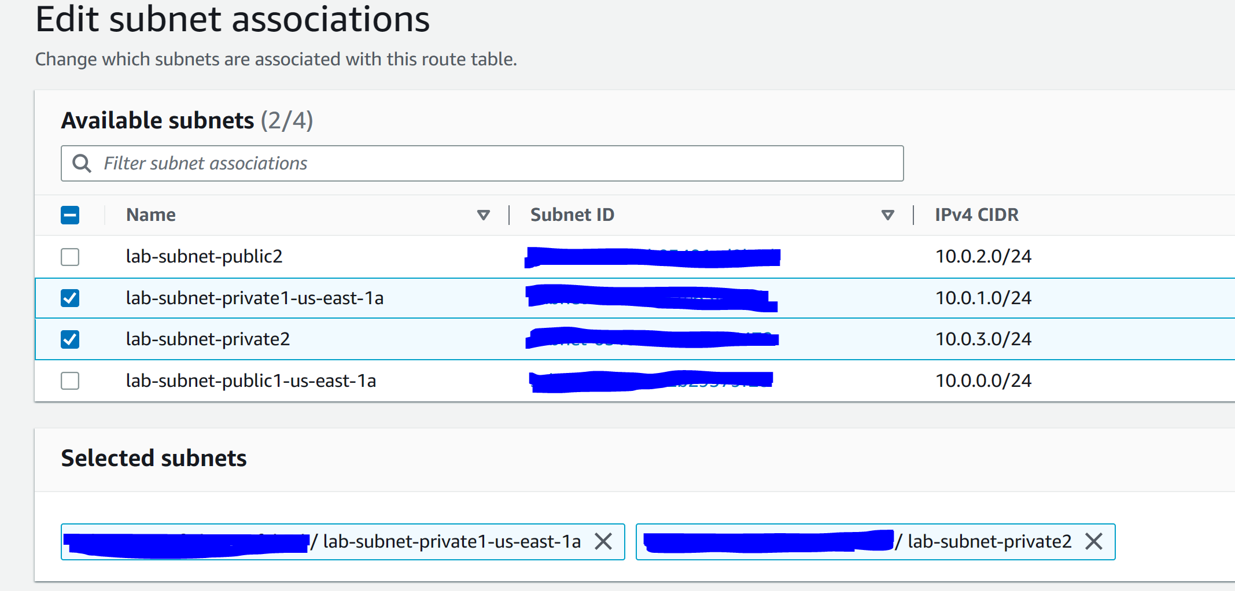

Step 13: Go to “routing tables”, click “lab-rtb-public” and got to “subnet associations”. Click “edit subnet associations.”

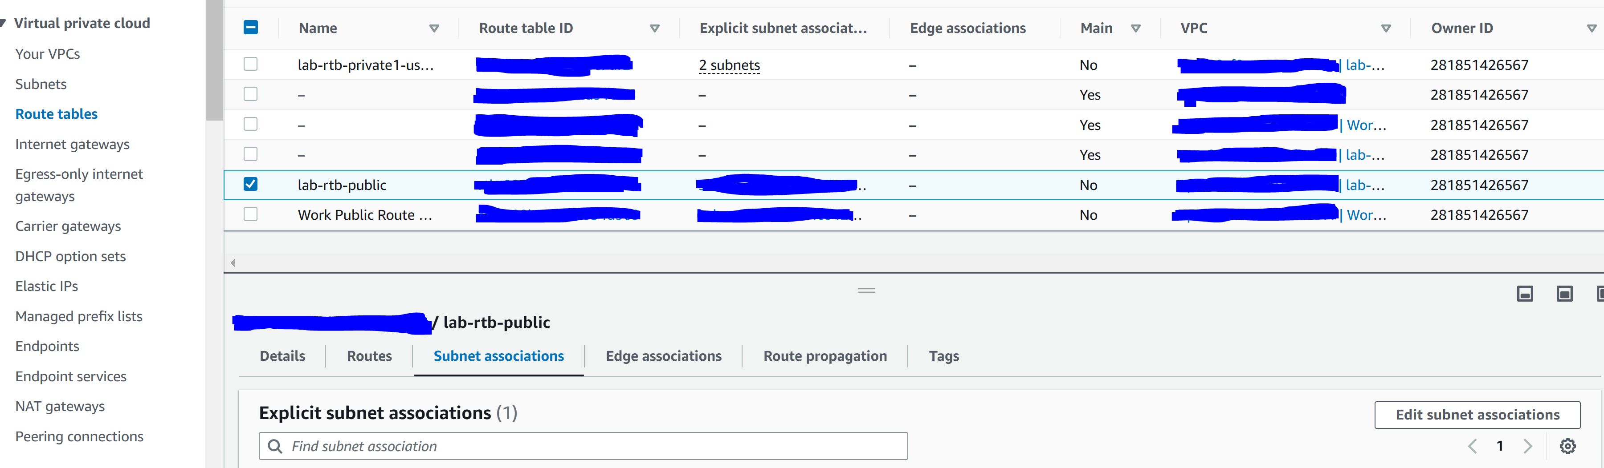

Step 14: select “lab-subnet-public2.” Click “save associations”

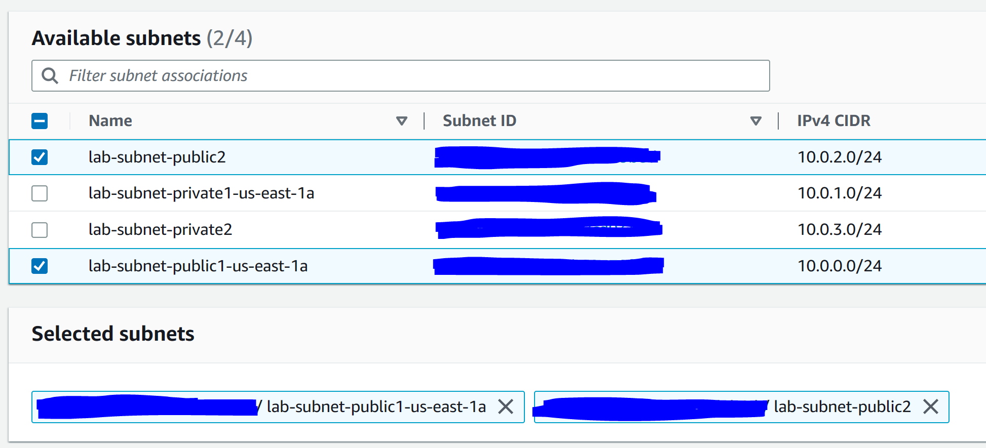

Step 15: go to “security groups” and click “create security group”

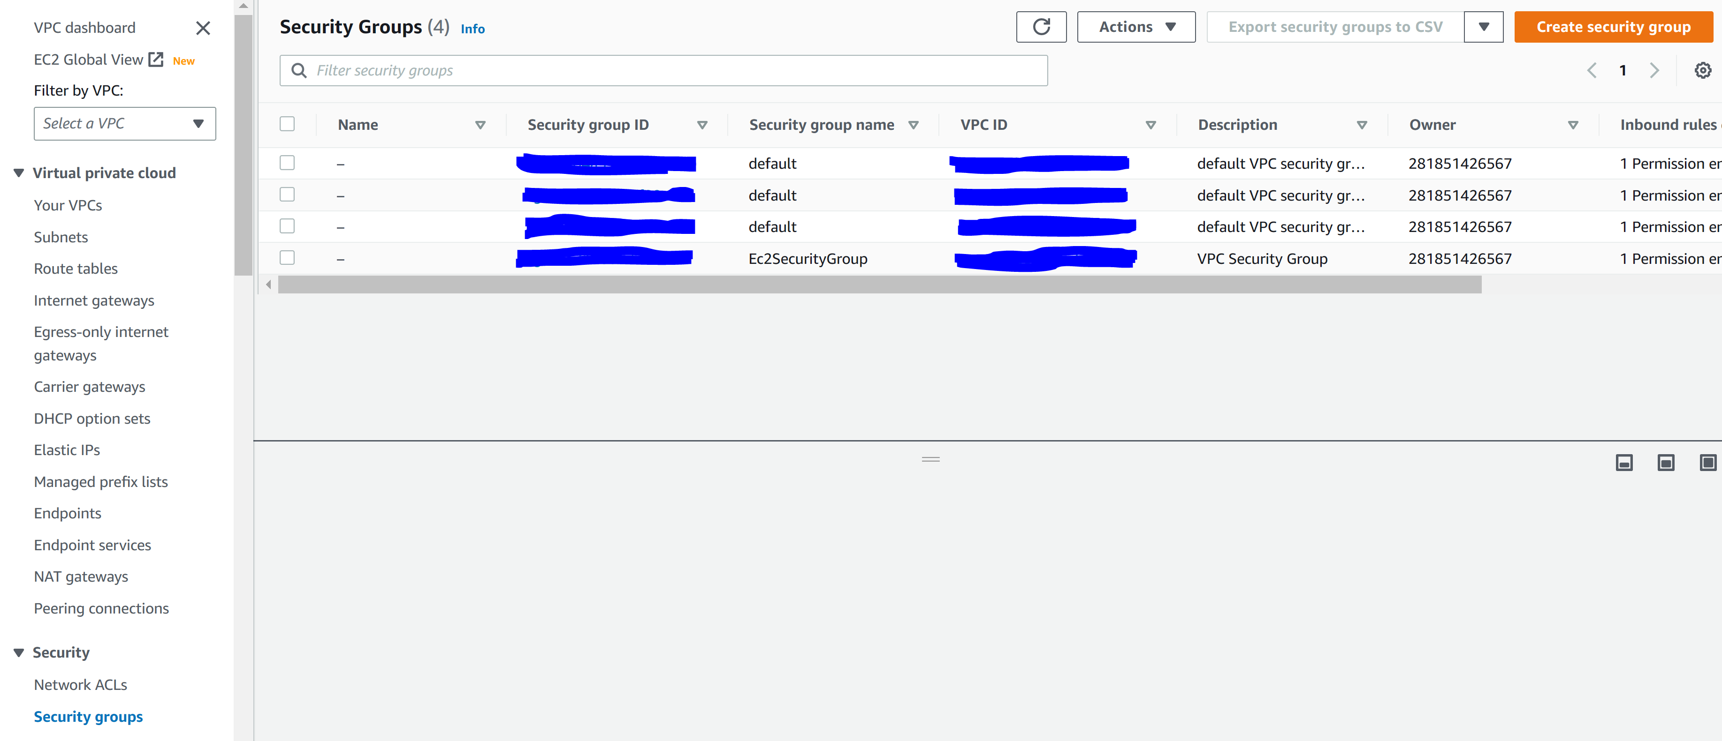

Step 16: configure the following. Create security group.

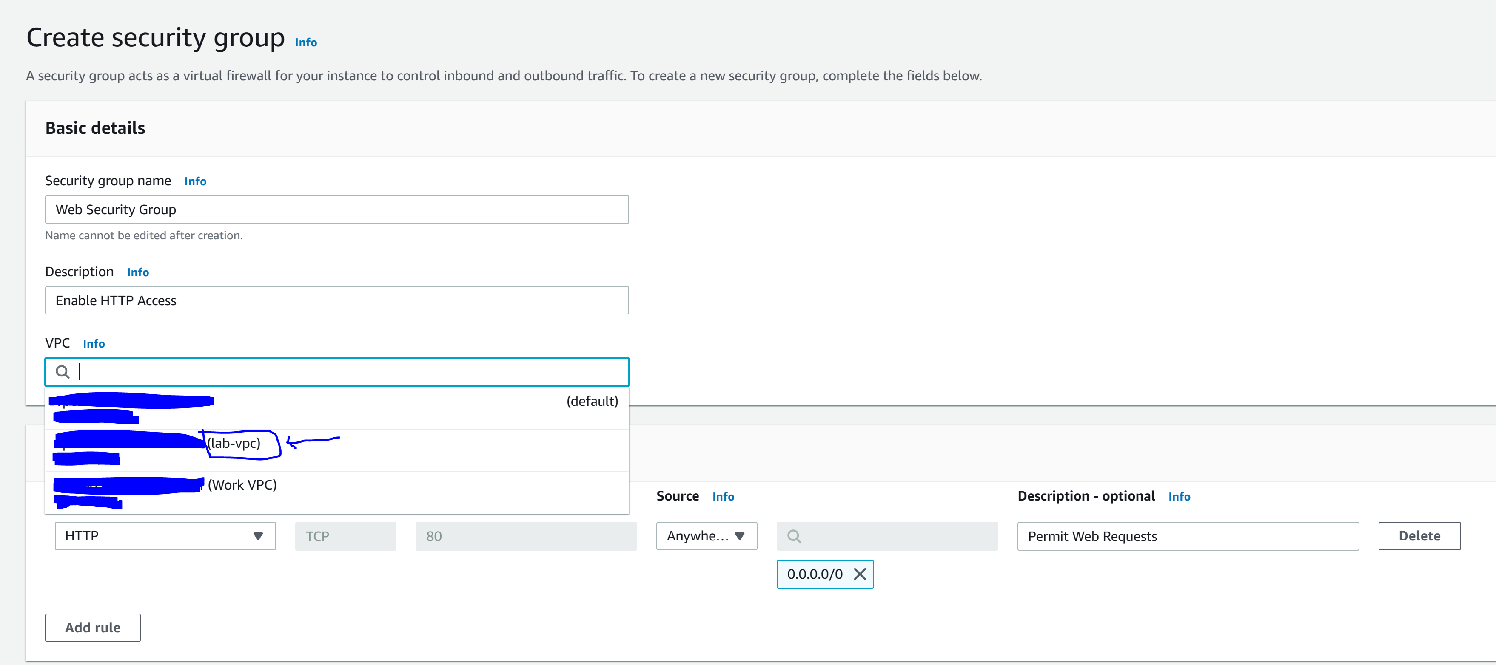

Step 17: got to AWS EC2

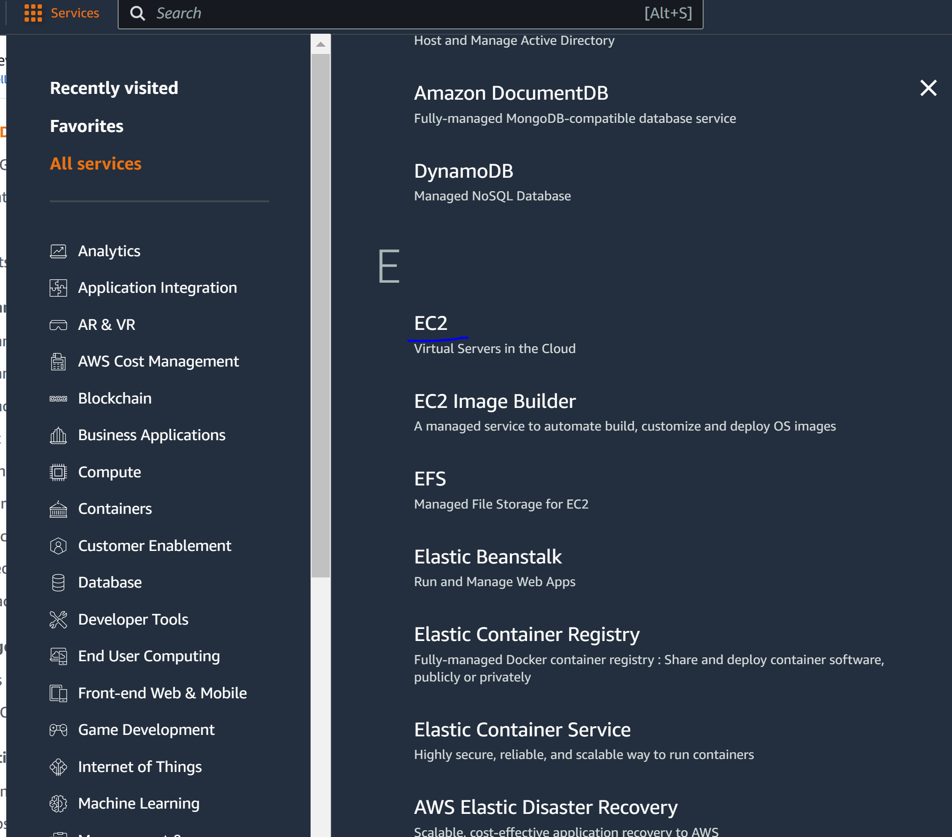

Step 18: Launch an instance

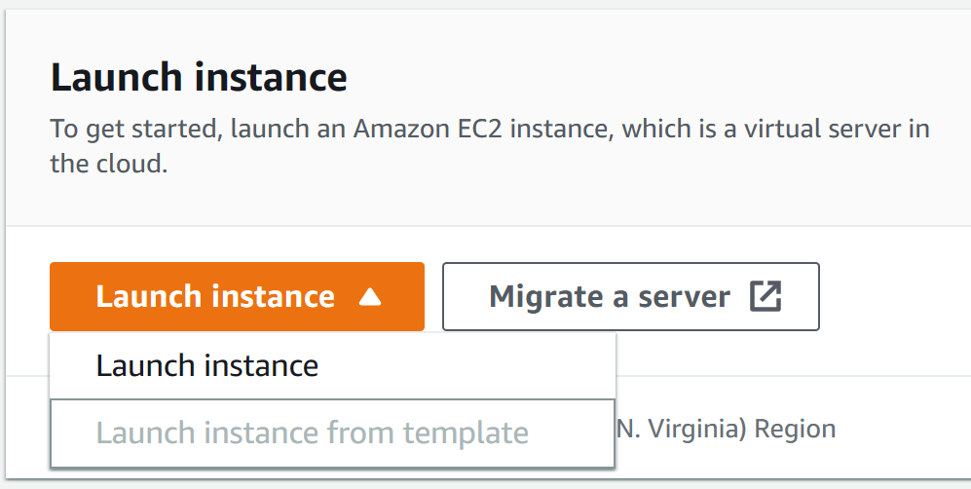

Step 19: configure the following

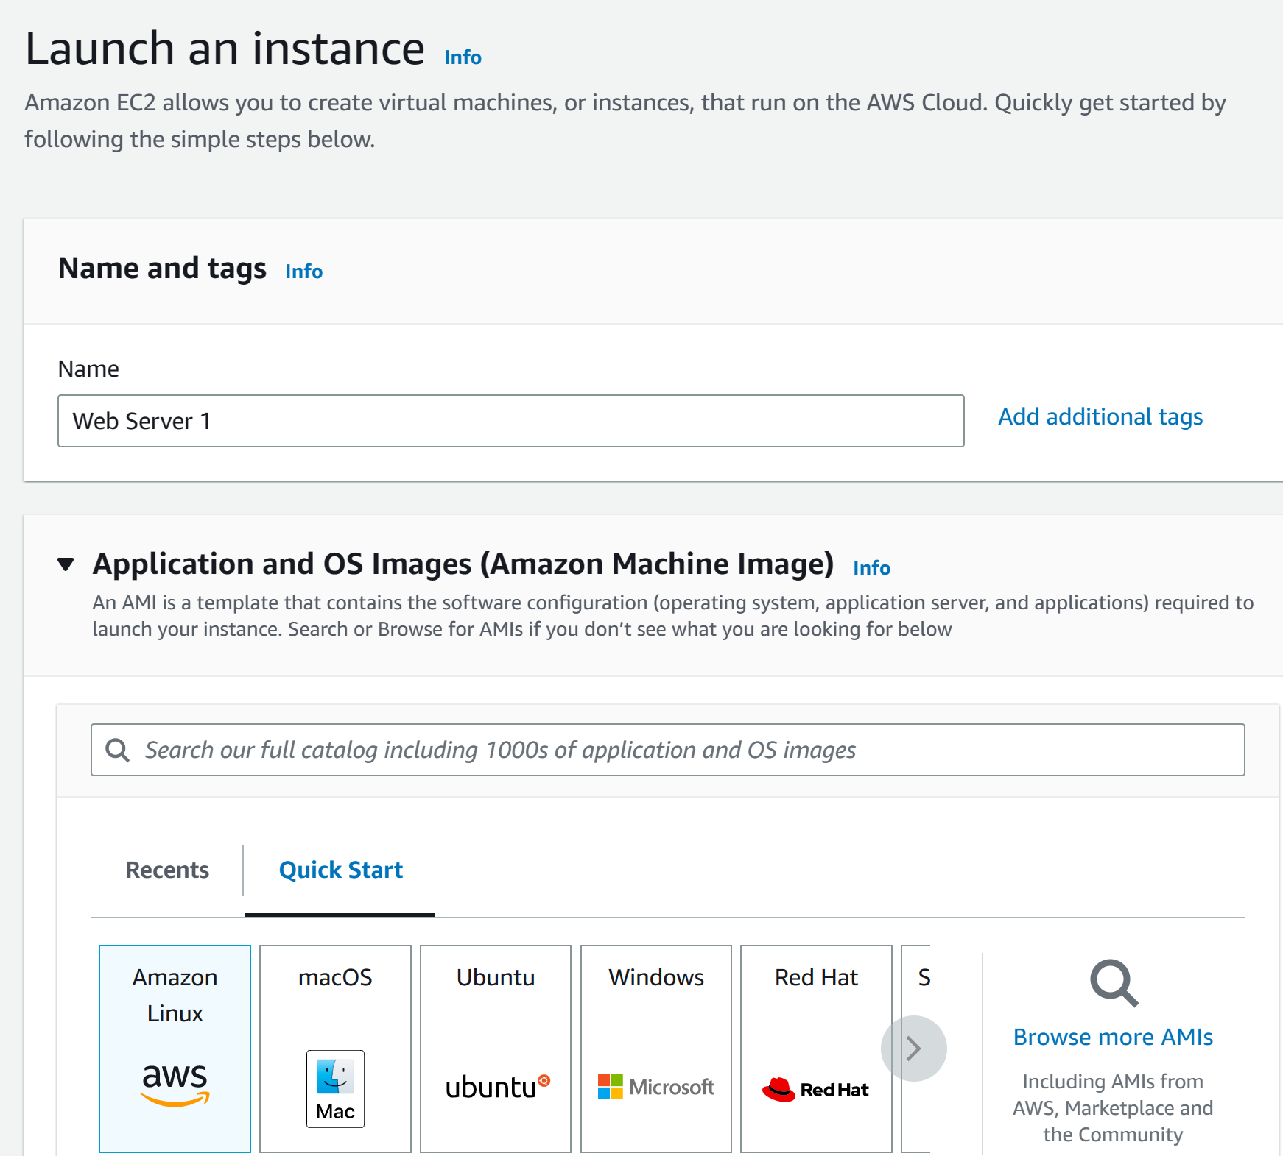

Step 20: configure the following

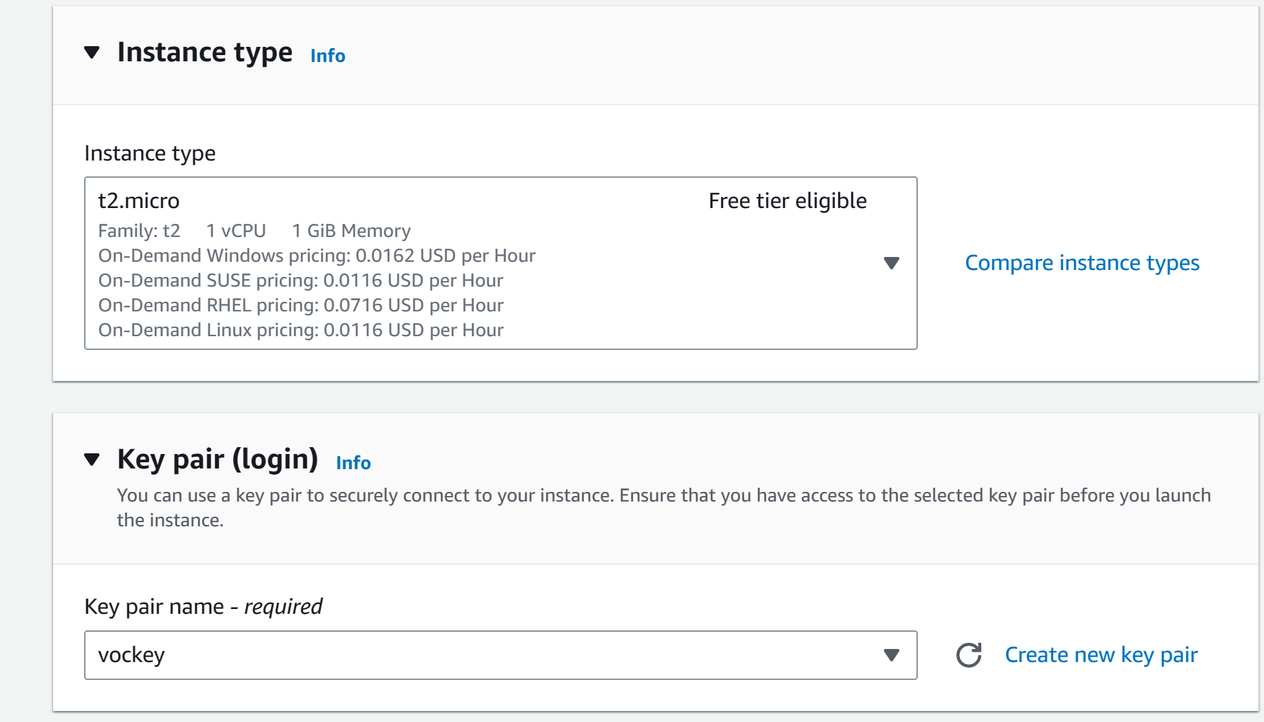

Step 21: configure the following

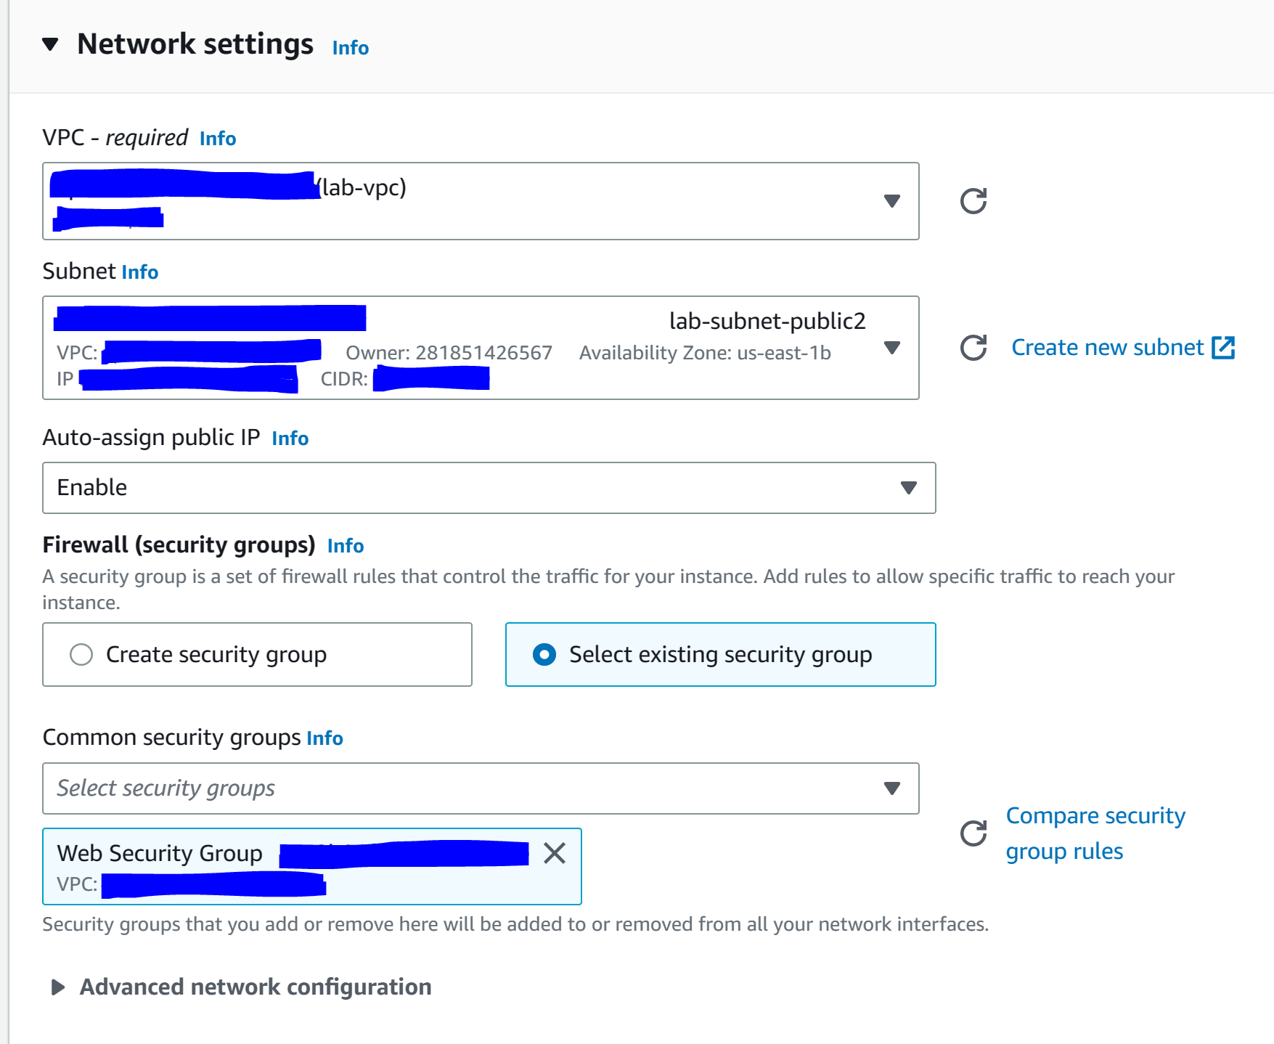

Step 21: configure the following under “advanced details”

Here is the text:

#!/bin/bash

# Install Apache Web Server and PHP

yum install -y httpd mysql php

# Download Lab files

wget https://aws-tc-largeobjects.s3.us-west-2.amazonaws.com/CUR-TF-100-ACCLFO-2-9026/2-lab2-vpc/s3/lab-app.zip

unzip lab-app.zip -d /var/www/html/

# Turn on web server

chkconfig httpd on

service httpd start

This script will run with root user permissions on the guest OS of the instance. It will run automatically when the instance launches for the first time. The script installs a web server, a database, and PHP libraries, and then it downloads and installs a PHP web application on the web server.

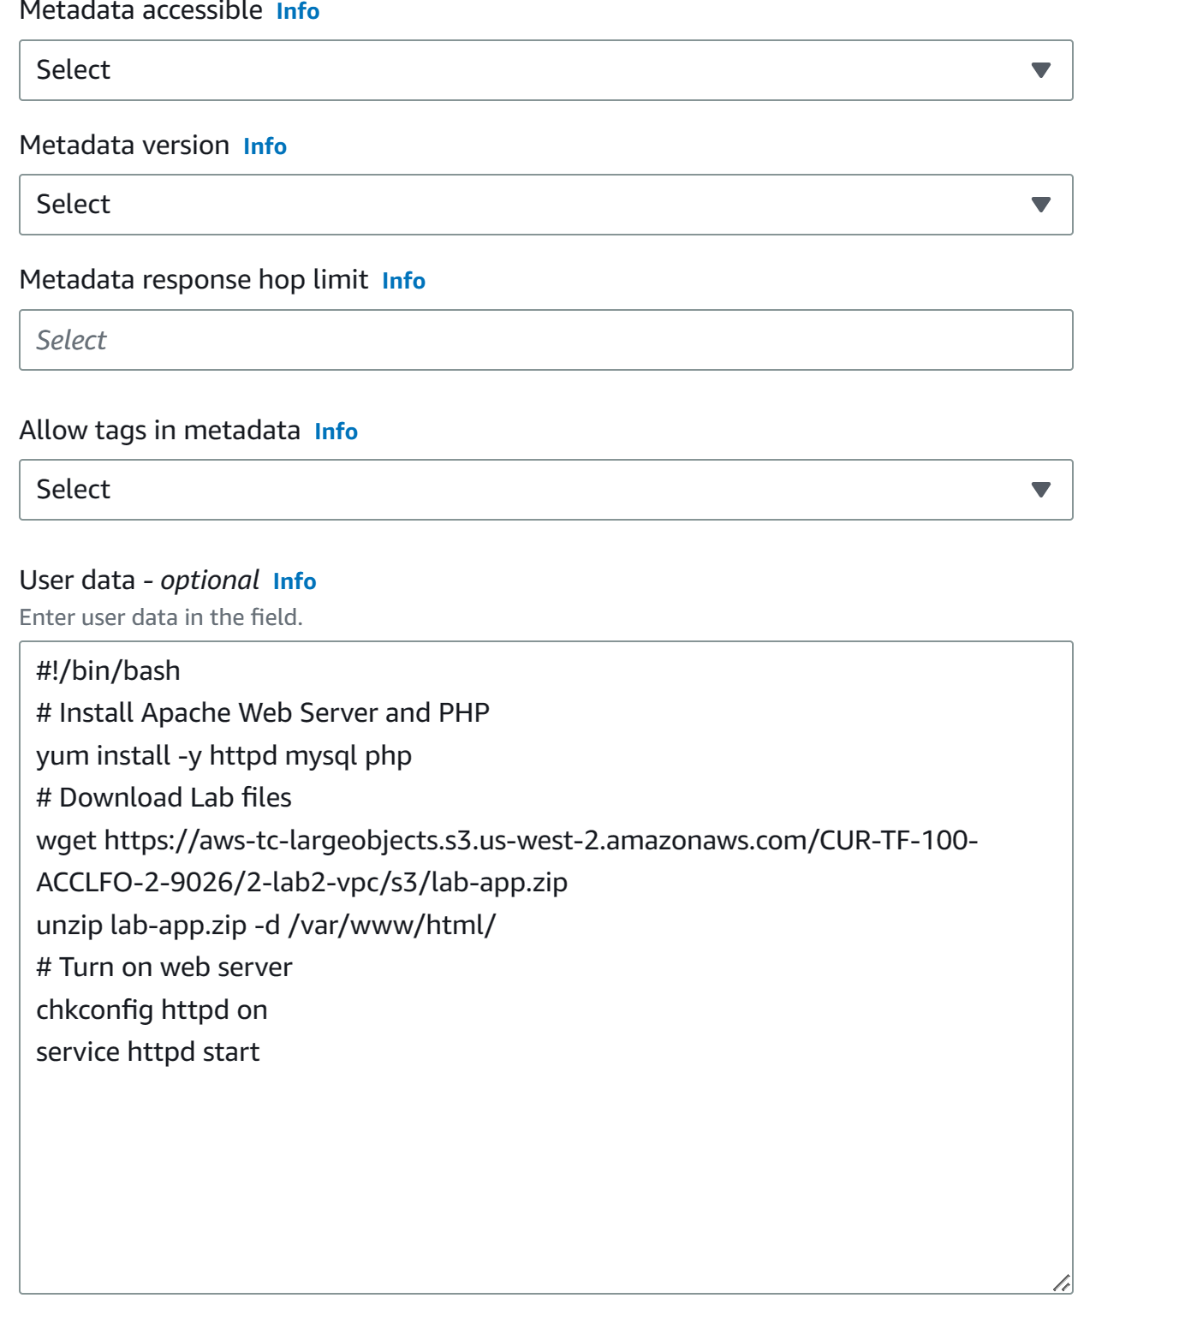

Step 22: Click “launch instance” and then “view instances”.

Step 23: wait for “Web Server 1” to finish 2/2 status checks

Step 24: go to “instances”, “web server 1” and copy the Public IPv4 DNS into a new tab.

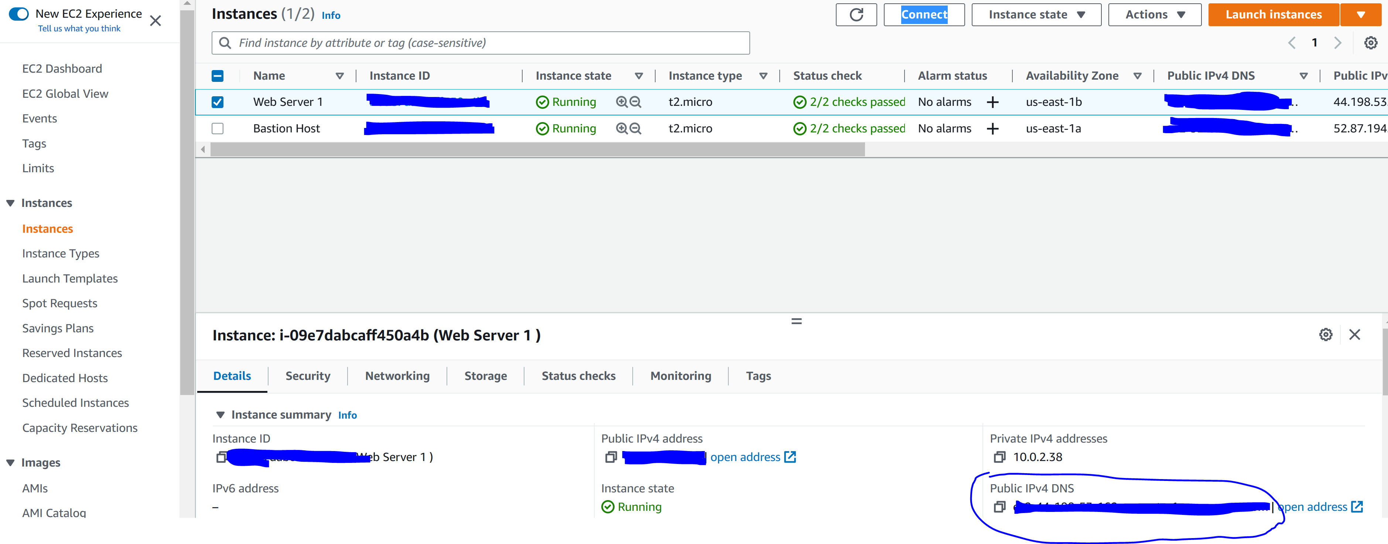

Step 25: click “end lab”

**Lab 3 Introduction to Amazon EC2**

Step 1: Start the lab

Step 2: Click AWS

Step 3: Go to Services, Compute, and EC2

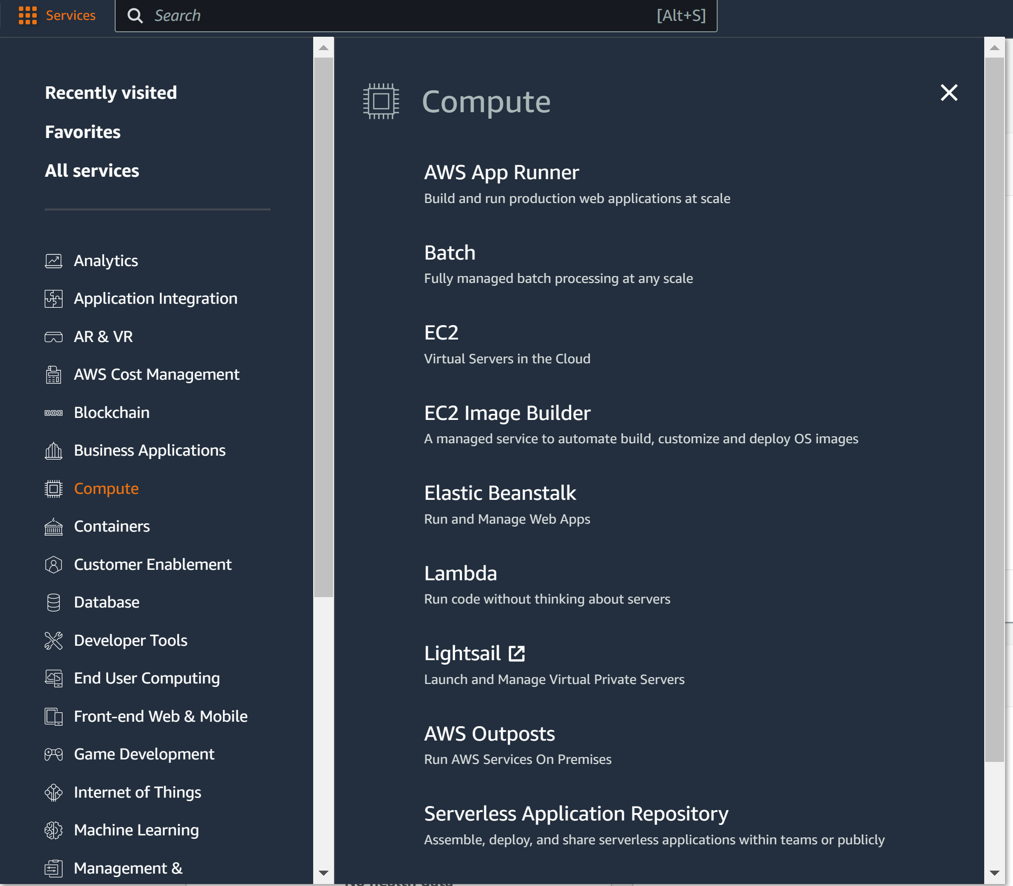\

Step 4: Click Launch Instance

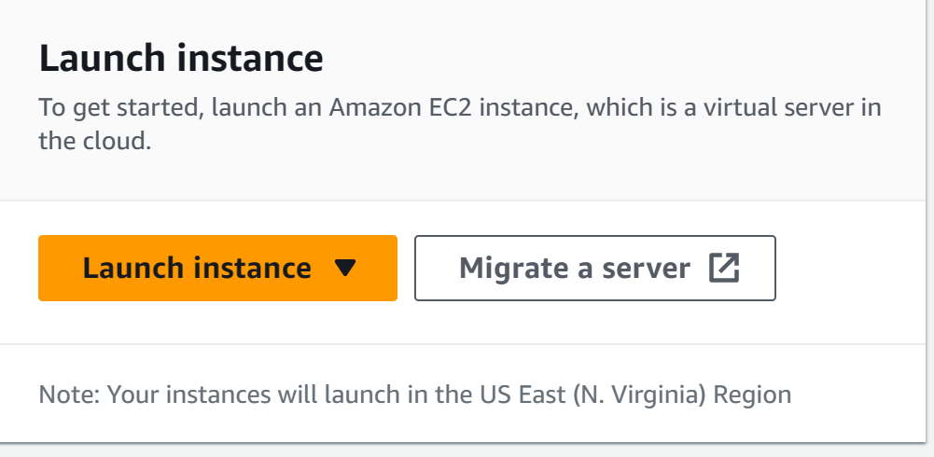

Step 5: configure the following:

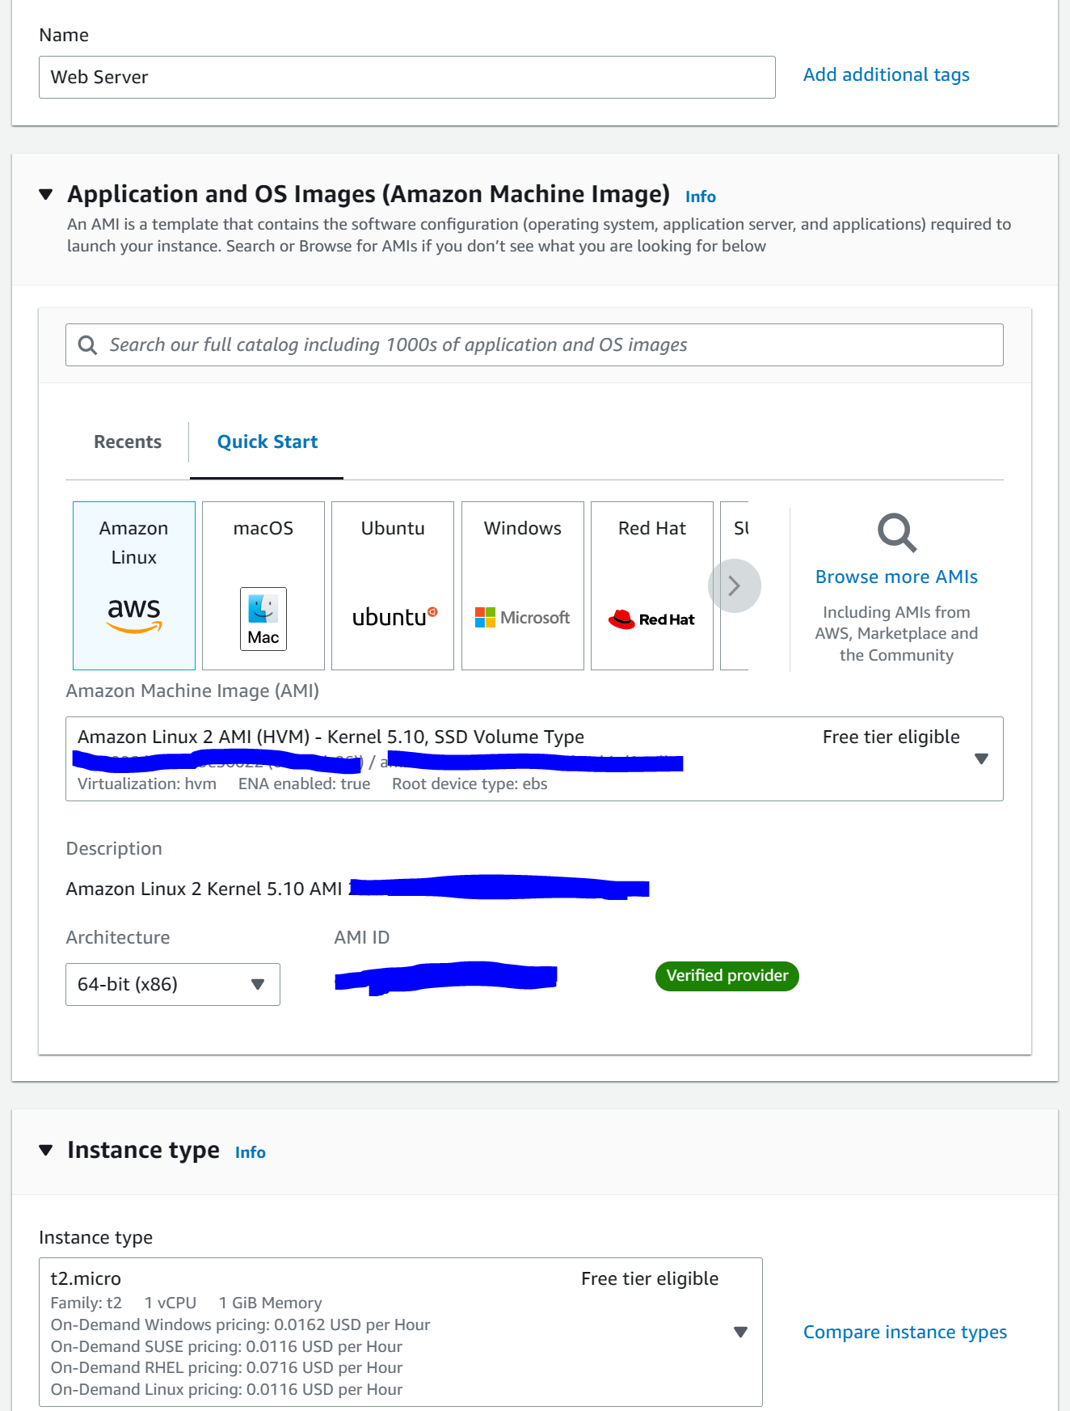

Step 6: configure the following

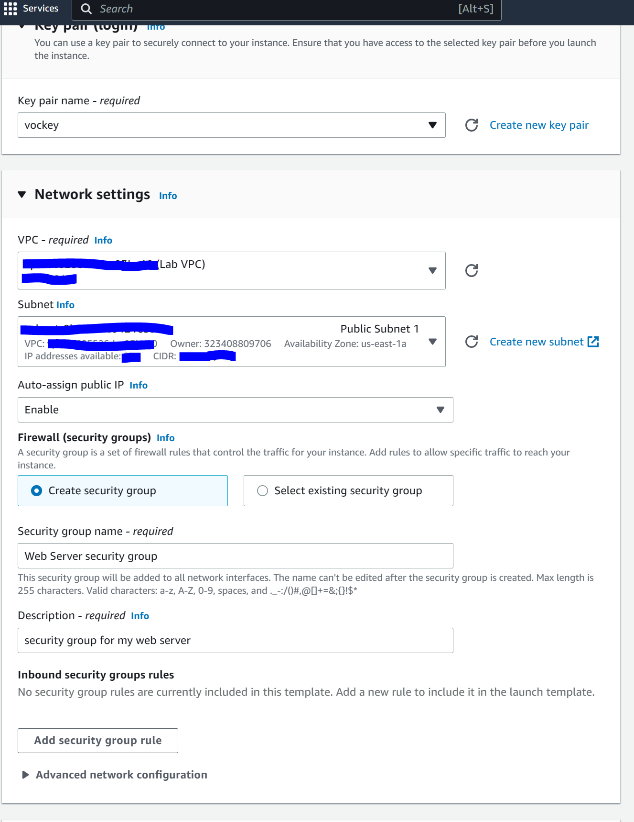

Step 7: open advanced details and configure the following

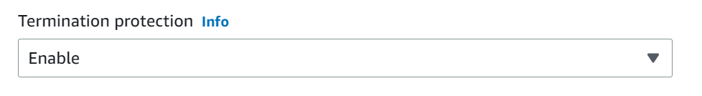

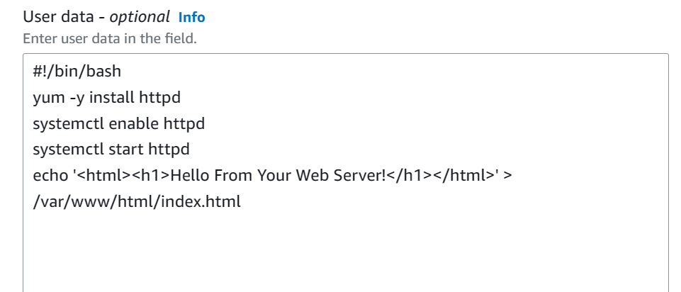

#!/bin/bash

yum -y install httpd

systemctl enable httpd

systemctl start httpd

echo '<html><h1>Hello From Your Web Server!</h1></html>' > /var/www/html/index.html

Step 8: press Launch Instance and View All Instances

Step 9: Wait for the status check to show 2/2 checks passed

Step 10: View Status Checks. They should both be green

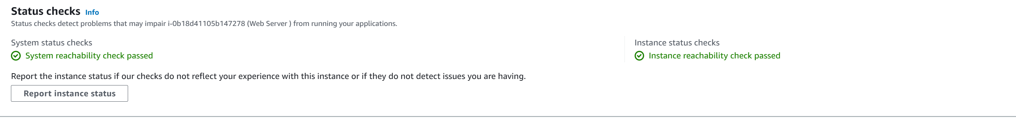

Step 11: got Actions, Monitor and Troubleshoot, and Get System Log

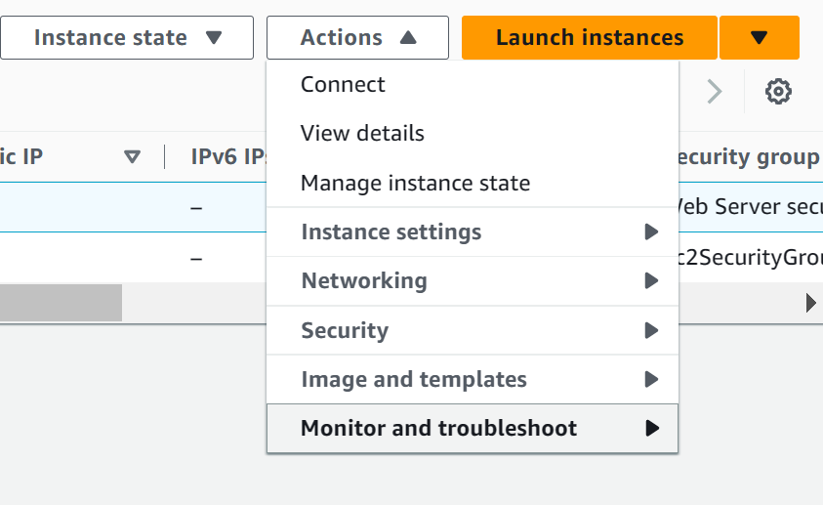

Step 12: You should be able to see the http package installed through the user data

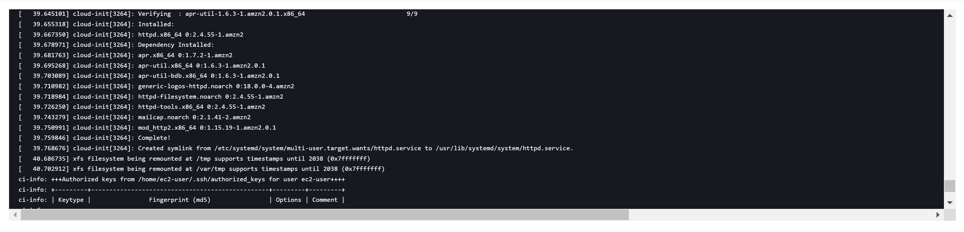

Step 13: go to Actions, Monitor and Troubleshoot, and Get Instance screenshot



Step 14: you should see a screenshot of the EC2 console screen

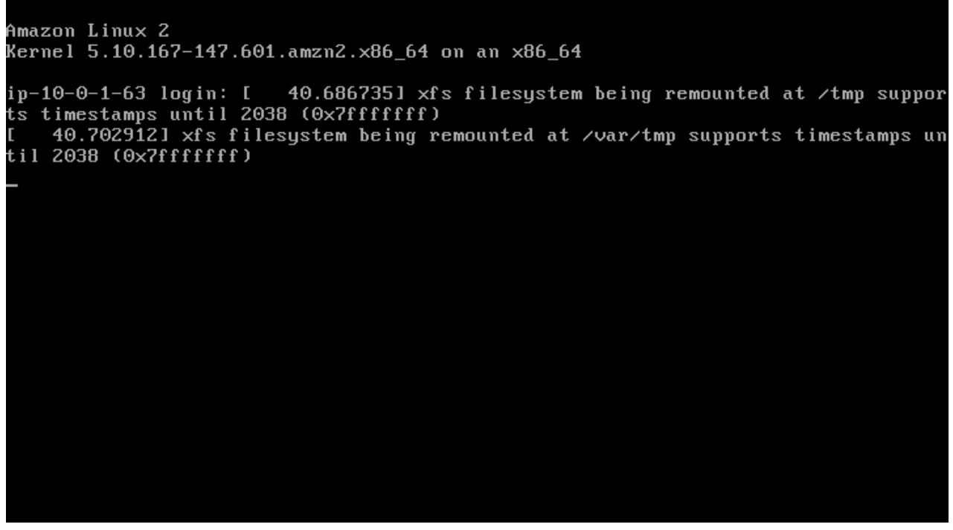

Step 15: go to details and copy the public IP address. If you access it right now, you shouldn’t be able to connect.

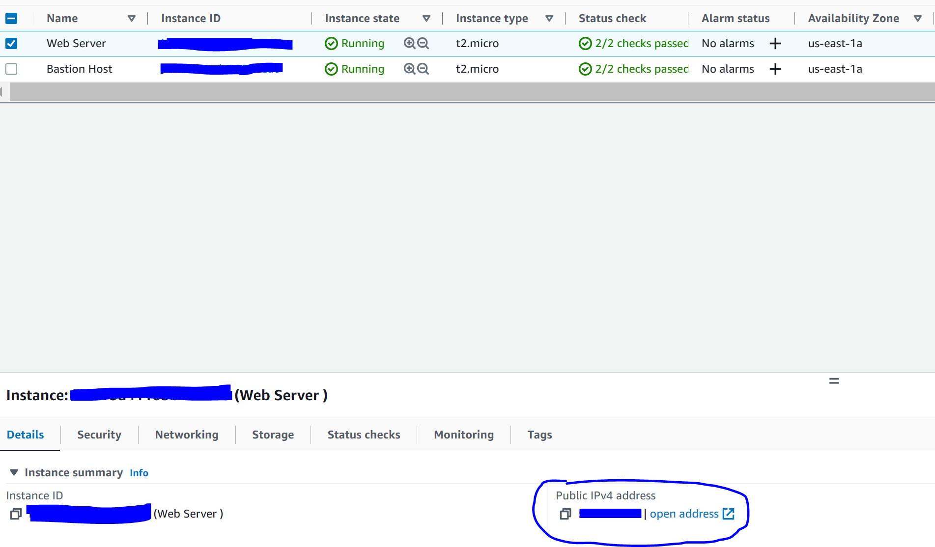

Step 16: got to Security Groups, Web Server Security Group, Inbound rules, and click edit inbound rules.

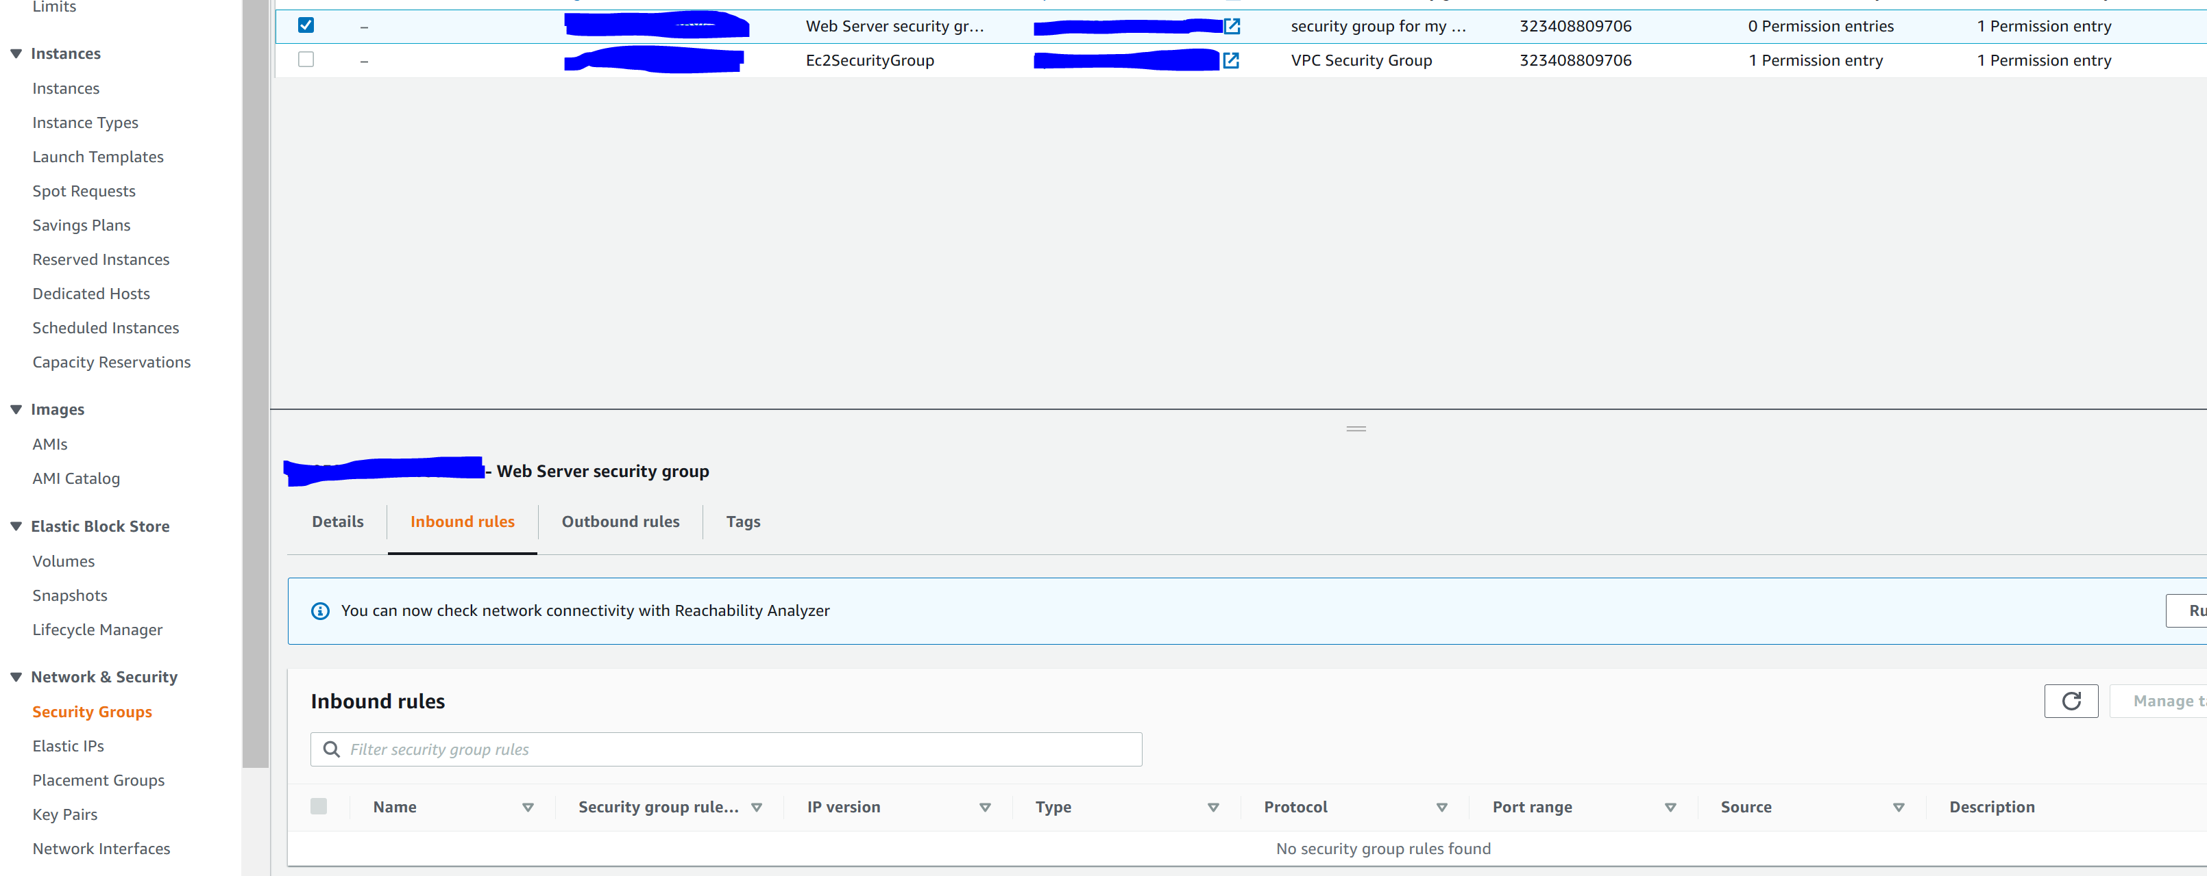

Step 17: configure the following

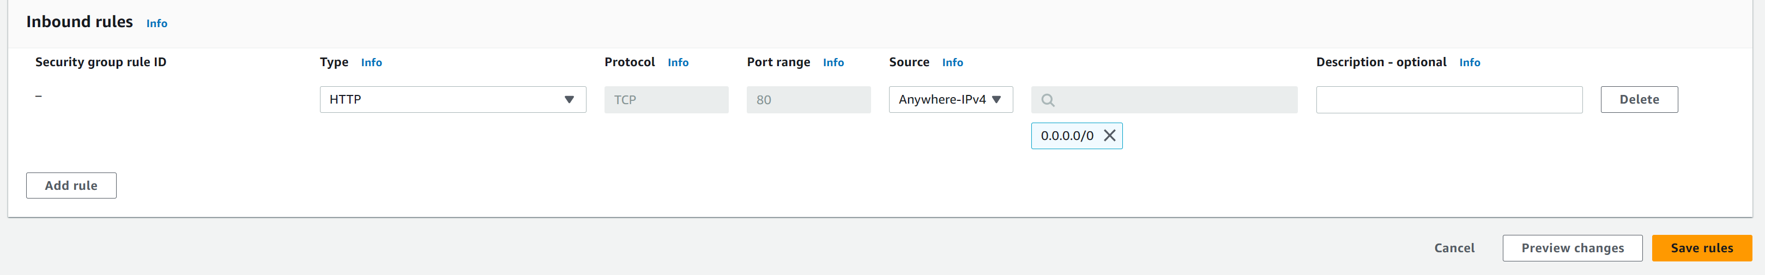

Step 18: visit the public IP address and you should see the following

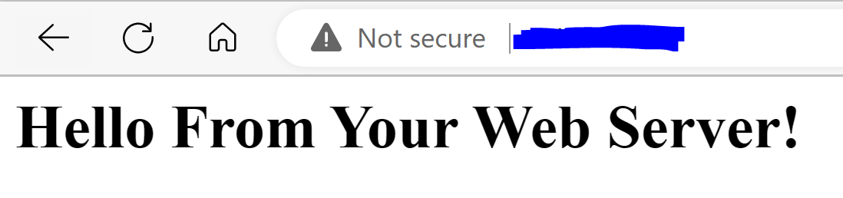

Step 19: go to instances, web server, instance state, and stop the instance. Wait for instance to stop.

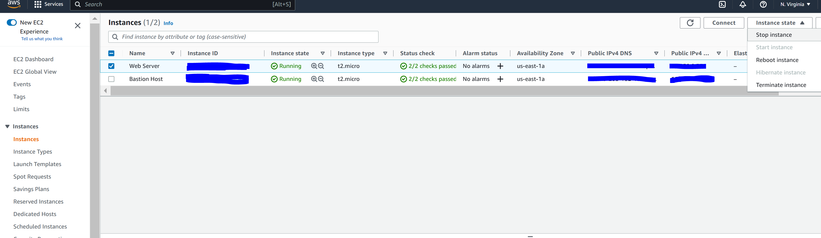

Step 20: go to Actions, Instance settings, and Change Instance Type

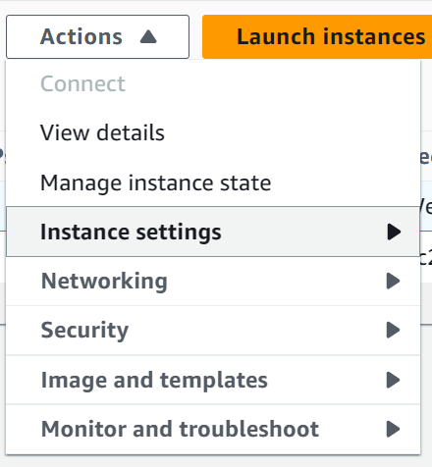

Step 21: configure the following

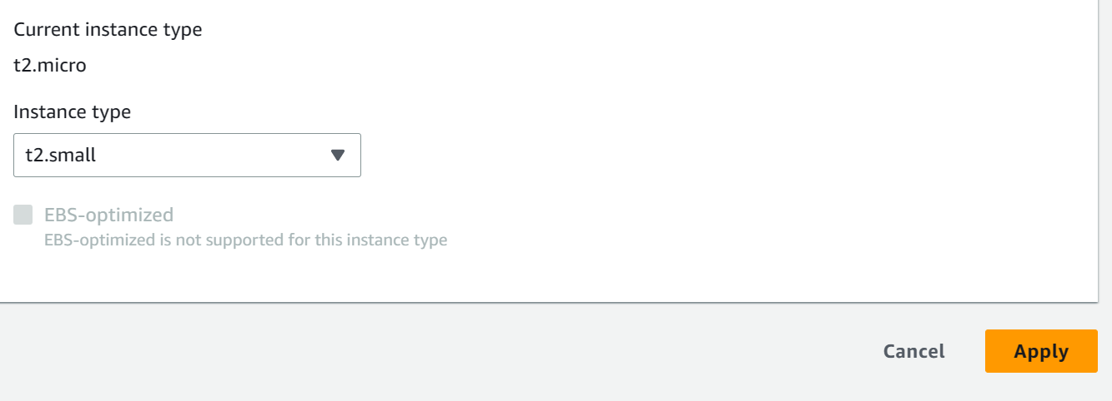

Step 22: Go to Storage and click the Volume ID.

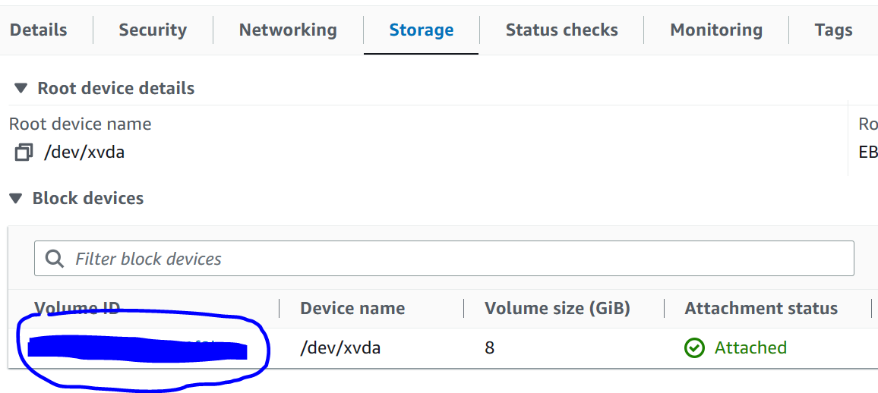

Step 23: Go to Actions, Modify Volume

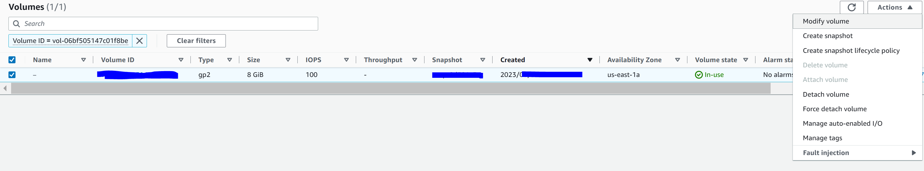

Step 24: configure the following

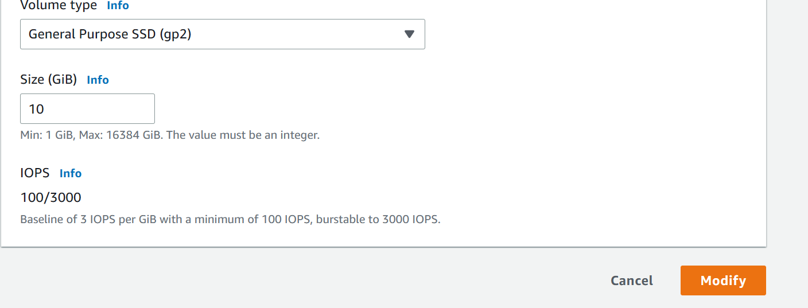

Step 25: Go to Instances, Web Server, Instance State, and Start Instance

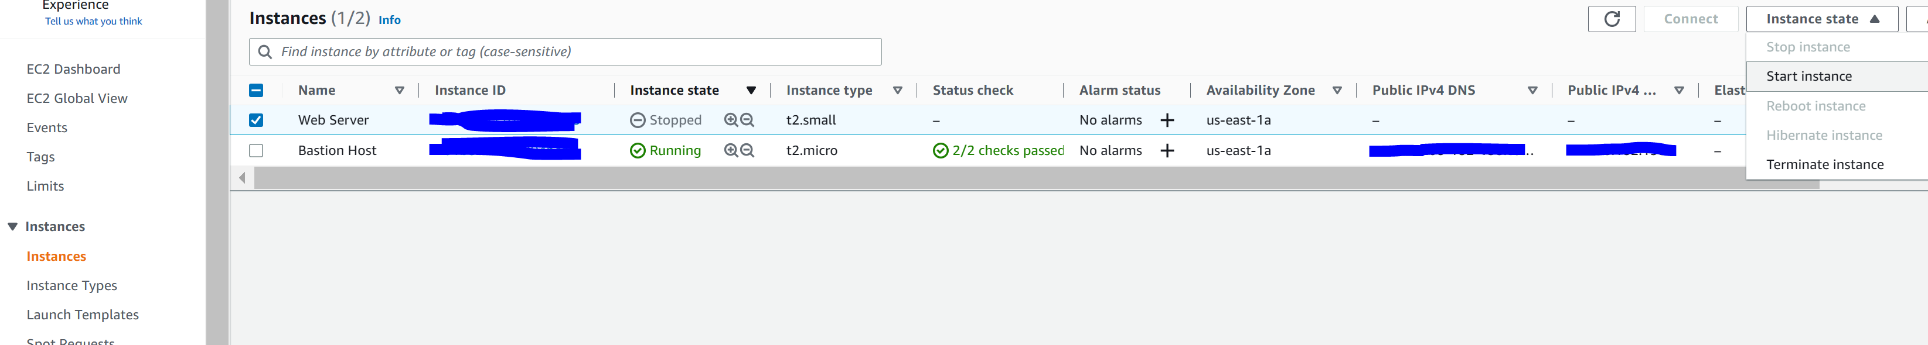

Step 26: we will now terminate (delete) the instance. Go to actions, instance settings, change termination protection

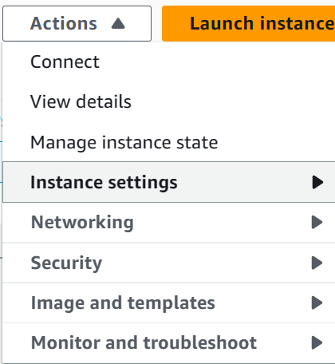

Step 27: configure the following

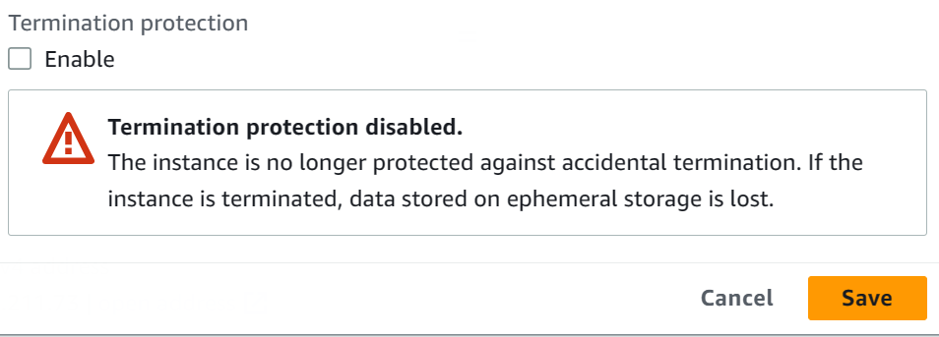

Step 28: Go to Instance State and Terminate Instance.

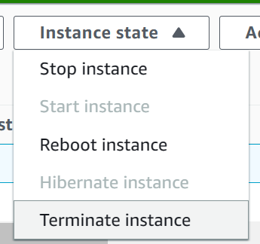

Step 29: Click End Lab

**Conclusion:**

In conclusion we learned how to use the basics of Amazon Web Services and hope to get certified.